

**GROUP ASSIGNMENT**

**TECHNOLOGY PARK MALAYSIA**

**OBJECT ORIENTED JAVA PROGRAMMING**

HAND OUT DATE: 1 DECEMBER 2023

HAND IN DATE: 23 FEBRUARY 2024

INTAKE CODE: APD2F2311CS(DA) / APU2F2311CS(DA) / APU2F2311CS

|  |  |
| --- | --- |
| ABDUL MUHAIMIN AMAN | TP069510 |

Table of Contents

1.0 INTRODUCTION 4

2.0 PROPOSED SYSTEM 5

3.0 SCOPE 6

4.0 OBJECTIVES 6

5.0 LIMITATIONS 7

6.0 SYSTEM DESIGN 8

6.1 USE CASE DIAGRAM (SYSTEM ACTIVITY) – Kertanaa A/P Kumaar 8

6.2 USE CASE DIAGRAM (CUSTOMER) 9

6.3 USE CASE DIAGRAM ( MANAGER) 10

6.4 USE CASE DIAGRAM (ADMIN) 11

6.5 CLASS DIAGRAM (SYSTEM ACTIVITY) – Abdul Muhaimin Aman 12

6.5.1 CLASS DIAGRAM DESCRIPTION 13

7.0 CONCEPTS USED 15

7.1 ABDUL MUHAIMIN AMAN 15

7.1.0 ENCAPSULATION 15

7.1.1 POLYMORPHISM 16

7.1.2 INHERITANCE 17

7.2 KERTANAA A\P KUMAAR 18

7.2.0 ENCAPSULATION 18

7.2.1 INHERITANCE: 19

7.3 HOUSHIANEE HARHANGI 20

7.3.0 INHERITANCE 20

7.3.1 ENCAPSULATION 20

7.3.2 ABSTRACTION 21

7.3.3 POLYMORPHISM 21

8.0 IMPLEMENTATION 22

8.1 ADMINISTRATOR- ABDUL MUHAIMIN AMAN 22

8.2 SALESPERSON - KERTANAA A/P KUMAAR 34

8.3 OFFICER – AREEBAH IRFAN MOHAMMED 47

8.4 AUTHORIZATION AND AUTHENTICATION – HOUSHIANEE HARHANGI 53

9.0 ADDITIONAL FEATURES 63

9.1 ABDUL MUHAIMIN AMAN 63

9.1.0 BACKGROUND IMAGE 63

9.1.1 STYLED BUTTONS 64

9.1.2 GRADIENT COLOUR BACKGROUND 65

9.1.3 TIMER FOR DIALOG BOX 66

9.1.3 ALTERNATING ROW COLOURS 67

9.1.4 CENTERING FRAME TO SCREEN 68

10.0 CONCLUSION 69

# 1.0 INTRODUCTION

In this project, we will create a window-based system to manage sales orders, invoicing, and reports for Yoyo-Furniture, a furniture firm. The system will be constructed in an object-oriented manner, with numerous objects representing real-world things like as sales orders, invoices, reports, and customers. The system will enable users to execute a variety of tasks, such as processing sales orders, producing invoices, generating reports, managing user accounts, updating and deleting, generating invoices, listing and modifying sales orders and so on.

With a user-friendly interface, the GUI-driven system will enable people to engage with it. The system will be built to handle a number of situations, such as processing sale orders, creating invoices using the data from the sales orders, producing reports that shed light on the sales success of the business, and maintaining user accounts.

We will use polymorphism, inheritance, and encapsulation—aspects of object-oriented programming—to create the system. Because of its modular architecture, the system will be simple to scale and maintain. Additionally, the system will be built with security in mind, incorporating user identification and authorization protocols.

An description of the system's architecture, implementation specifics, and samples of code showcasing its object-oriented capabilities are all included in this report. In addition, we will include images of the user interface and a thorough explanation of all the features that the system will support.

# 2.0 PROPOSED SYSTEM

A window-based system that mimics the workflow of handling sale orders, invoicing, and reports is the proposed system for Yoyo-Furniture. An object-oriented design methodology will be used to create the system, with different objects standing in for actual real-world things including users, reports, invoices, and sale orders. Users with varying levels of access, including officers, administrators, and salespeople, will be able to handle sale orders and reports through the system.  
  
The officer will be able to use features including creating reports, monitoring the status of sold products, processing sale orders when a transaction is approved or closed, and maintaining personal accounts. In addition to searching and editing sale orders, the officer will be able to submit sales for production, issue sale invoices, and generate reports like the work-done and approved/closed sale reports.

The administrator will be able to perform tasks such as generating reports and handling employee and personal accounts. In addition to creating reports like the work done report and the approved/closed sale report, the administrator will have the ability to manage the profiles of officers and salesperson

The salesperson will be able to manage personal profiles, sale order quotations, and view a list of all personal sales orders. The salesperson will be able to generate, alter, remove, and search sale order quotations, as well as  list of all disapproved and authorized personal sales orders.

We shall list the different properties required to describe the entities (sale order, invoice, report, user,) in the solution architecture. Additionally, we will list and include the techniques required for every entity, including report generation, modification, removal, and search. The system will verify data integrity and look for duplicate entries.  
  
To get at the object-oriented design principles, we will logically assume certain functional needs. For permission and authentication reasons, for instance, we will assume that every user has a distinct username and password. Additionally, we will presume that every sale order has a distinct ID in order to avoid duplication and guarantee precise tracking.

# 3.0 SCOPE

1. For a furniture firm, design and construct a window-based system to manage selling orders, invoicing, and reports.
2. To represent real-world elements like sale orders, invoices, reports, and users, utilize an object-oriented approach.
3. Assign distinct access privileges to officers, administrators, and salespeople.
4. Put into practice features like report generation, modifying, removal, and searching.

# 4.0 OBJECTIVES

1. Make the management of sale orders, invoicing, and reports easier to use using an intuitive UI.
2. Use object-oriented design concepts to create representations of real-world objects.
3. Implementing access permissions and authentication will help to ensure data security and integrity.
4. Execute features including report generation, editing, deletion, and searching.  
   To make sure the system is bug-free and satisfies functional requirements, test it.

# 5.0 LIMITATIONS

1. The system won't be linked to an actual database or production environment; instead, it will be a simulation.
2. In a real-world scenario, the system might not account for every event that could occur.
3. Because the system is a simulation rather than an application that is ready for production, it can have constraints with regard to performance, scalability, and security.
4. It's probable that not every edge case and error handling situation is covered by the system.
5. It's possible that the system cannot be adjusted or configured to satisfy certain company needs
6. It's possible that the system hasn't been thoroughly tested and has errors or problems that weren't discovered during development.
7. It's possible that not all hardware setups or operating systems will work with the system.
8. Users with impairments might not be able to access the system completely.
9. It's possible that the system isn't completely adjusted for varying screen sizes and resolutions.
10. It's possible that the system does not adhere to all rules and industry norms.
11. It's possible that the system can't manage a lot of data or many users at once.
12. There's a chance that the system won't work with other apps or platforms.
13. It's possible that the system can't manage processes or complicated business rules.
14. It's possible that the system cannot deliver analytics or data in real time.
15. Requirements for translation or internationalization could be beyond the system's capabilities.

# 6.0 SYSTEM DESIGN

## 6.1 USE CASE DIAGRAM (SYSTEM ACTIVITY)

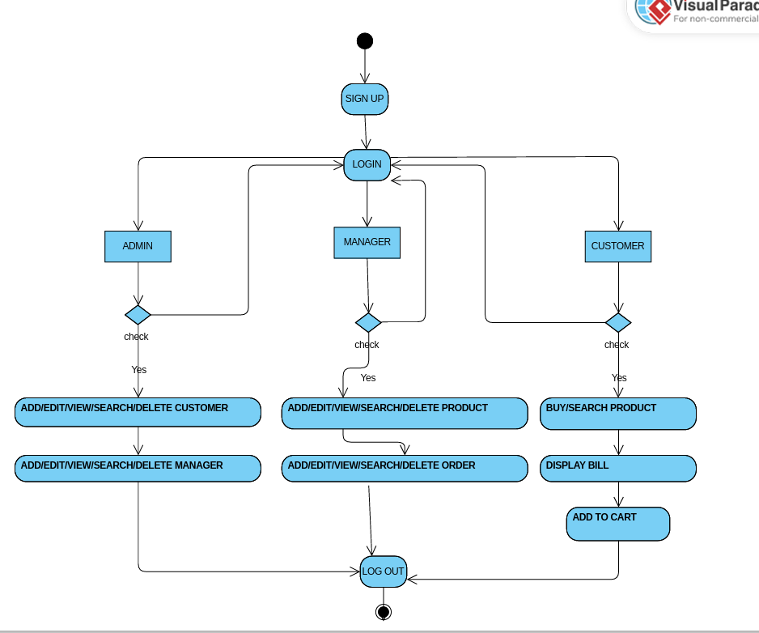

*Figure 1 shows the Activity Diagram*

System users has to login to the system using valid username and password. Depending on their categories so that they will be able to open their respective pages.

## 6.2 USE CASE DIAGRAM (CUSTOMER)

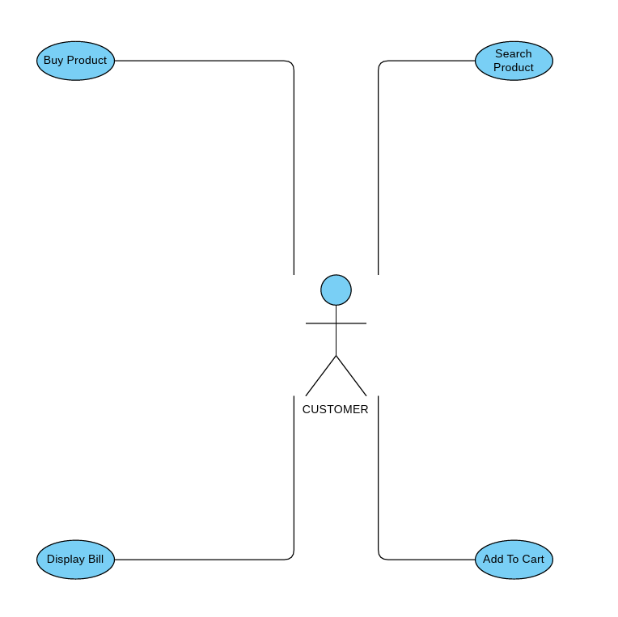

*Figure 2 shows the Use Case Diagram of Customer*

According to the use case diagram, the Customer role's interactions are mostly focused on product browsing, ordering, and shipping tracking. Customers may go through the products that are offered, choose the things that they want to buy, and then place their purchases. They may also track shipments to keep an eye on the delivery process and examine the status of their orders.

## 6.3 USE CASE DIAGRAM ( MANAGER)

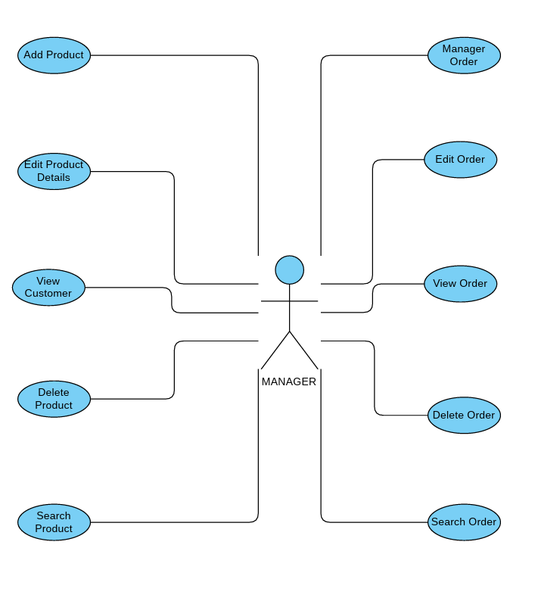

*Figure 3 shows the Use Case Diagram of Manager*

The Manager job holds more power and is largely responsible for approving or rejecting sales orders. After reviewing outstanding sales orders, managers decide whether to approve or reject them based on several factors, including availability, cost, and client preferences. Furthermore, managers have access to sales reports, which give them insightful knowledge about systemic patterns and overall sales success.

## 6.4 USE CASE DIAGRAM (ADMIN)

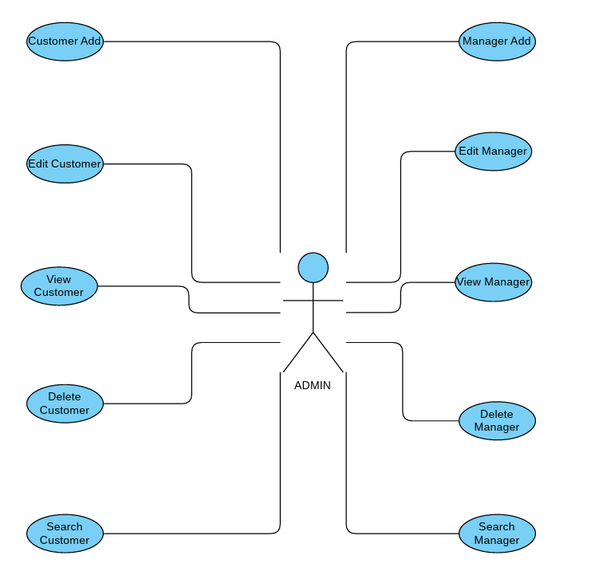

*Figure 4 shows the Use Case Diagram of Admin*

In contrast, the admin function oversees overseeing and managing the system. Administrators have the power to add, edit, and remove employees from the system, such as officers and salespeople, from their profiles as needed. Moreover, administrators have access to reports and sales data, which gives them the ability to assess system performance and decide after gaining knowledge.

## 6.5 CLASS DIAGRAM (SYSTEM ACTIVITY)

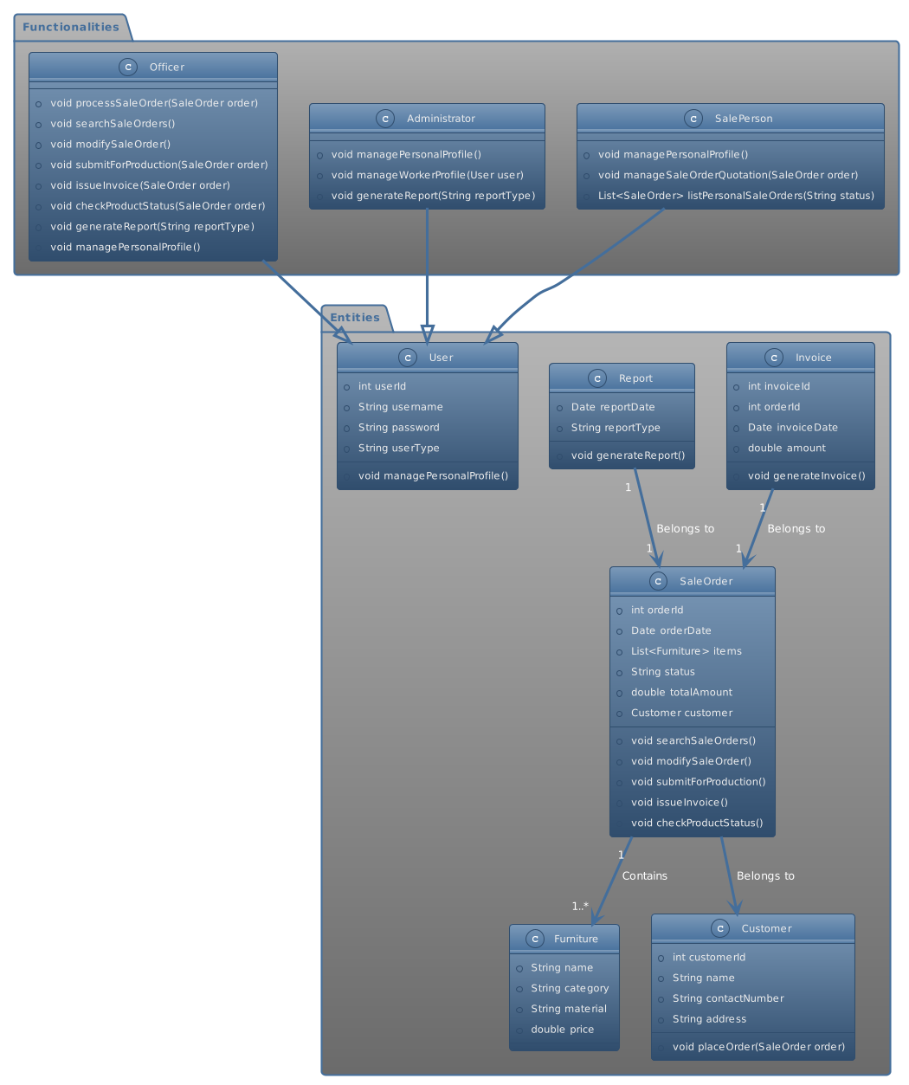

### 6.5.1 CLASS DIAGRAM DESCRIPTION

| **Entity/Functionality** | **Attributes** | **Brief Description** |
| --- | --- | --- |
| Officer | - userID<br>- username<br>- password<br>- userType (officer)<br> | Represents an officer with access to specific functionalities, such as processing sale orders, generating reports, and managing personal profiles. |
| Administrator | - userID<br>- username<br>- password<br>- userType (administrator)<br> | Represents an administrator with access to managing personal profiles, worker profiles, and generating reports. |
| Customer | - customerID<br>- name<br>- contactNumber<br>- address<br> | Represents a customer, with attributes for customer ID, name, contact number, and address. |
| Furniture | - name<br>- category<br>- material<br>- price<br> | Represents a furniture product, with attributes for name, category, material, and price. |
| Report | - reportDate<br>- reportType<br> | Represents a report, with attributes for report date and report type. |
| Sales Invoice | - invoiceID<br>- invoiceDate<br>- amount<br>- order<br> | Represents a sales invoice, with attributes for invoice ID, invoice date, amount, and order. |
| processSaleOrder(SaleOrder order) | - order<br> | A functionality for officers to process a sale order upon sale approval or closed sale. |
| generateReport(String reportType) | - reportType<br> | A functionality for officers and administrators to generate reports based on report type. |
| managePersonalProfile() | - user<br> | A functionality for users to manage their personal profile. |
| placeOrder(SaleOrder order) | - order<br>- customer<br> | A functionality for customers to place an order by providing the order and customer details. |

# 7.0 CONCEPTS USED

### 7.1 ENCAPSULATION

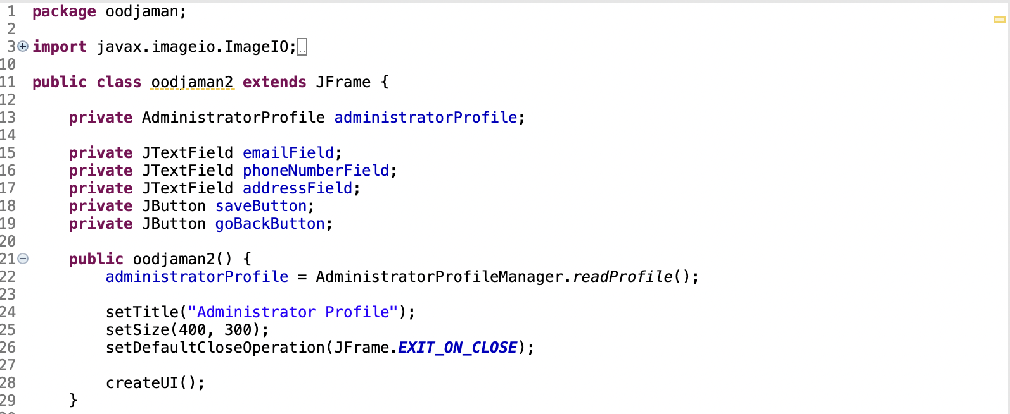

Encapsulation is implemented in the oodjaman2 class using private methods (createUI(), saveChanges(), createStyledButton(String text)), private inner class (BackgroundPanel), and private fields (administratorProfile, emailField, phoneNumberField, addressField, saveButton, goBackButton). These aspects are protected from external classes by being marked as private, which limits access to the class itself and hides the internal state and implementation details. By enabling limited access to the class's functionality and encouraging information concealment, this encapsulation helps to create a more modular and manageable construction.

### 7.2 POLYMORPHISM

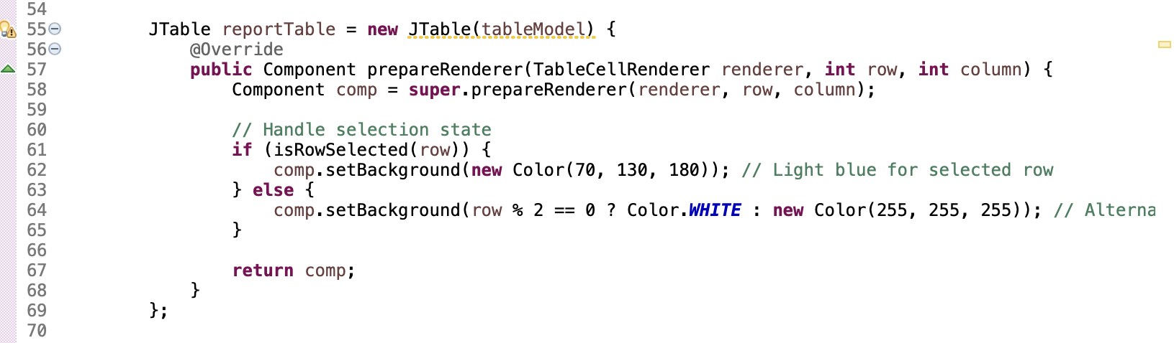

This code snippet overrides the prepareRenderer function to adjust table cell rendering based on selection status and row index. This is an example of polymorphism, as the overridden method offers a customized implementation inside the context of ClosedSaleReport.

### 7.3 INHERITANCE

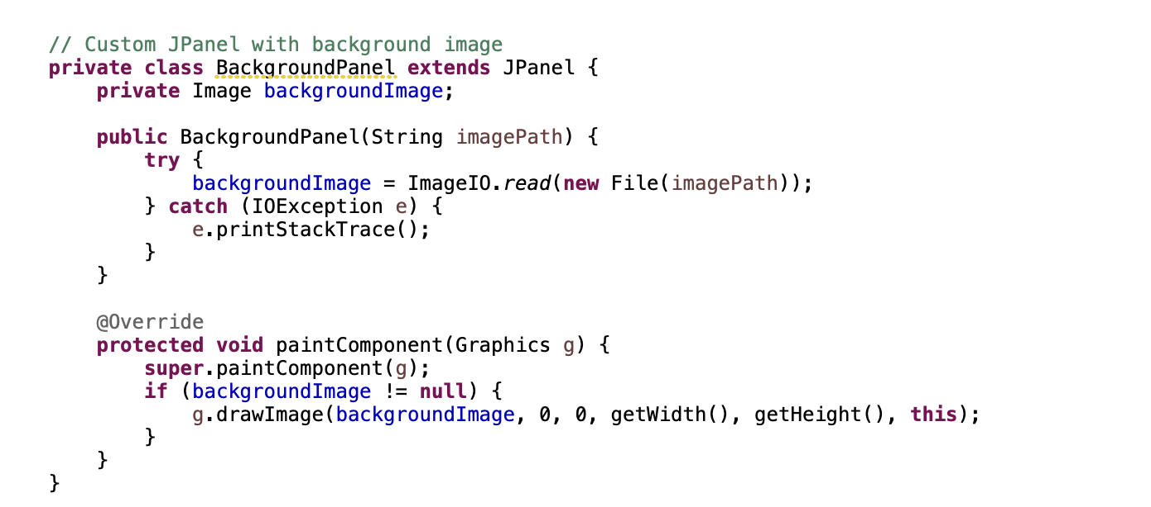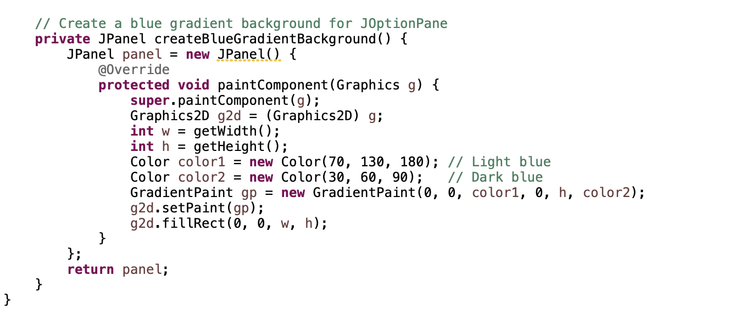

Java inheritance is demonstrated by the BackgroundPanel class and the createBlueGradientBackground function, which both extend or generate a subclass of the JPanel class. The custom panels offers extra or altered functionality while inheriting the JPanel class's attributes and behaviours.

### 7.4 ENCAPSULATION

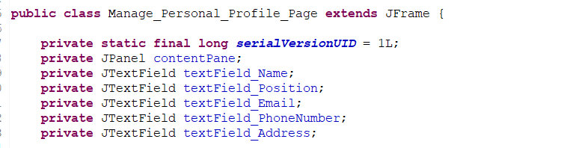

From the code shown above, all the variables have been declared with a private access method which promotes encapsulation that hide all the data from being modified by non-relevant objects, as opposed to structured programming in that data will act as global data without any privilege access method to control the access. Furthermore, for above variables to be accessed, mutator and access method must be implemented.  

## 7.5 INHERITANCE:

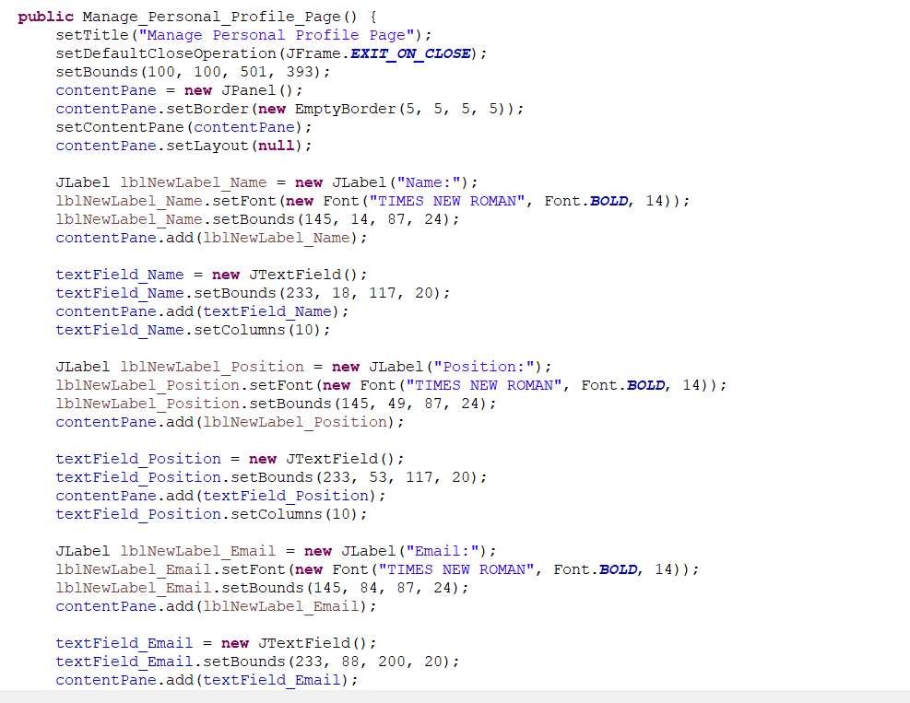  
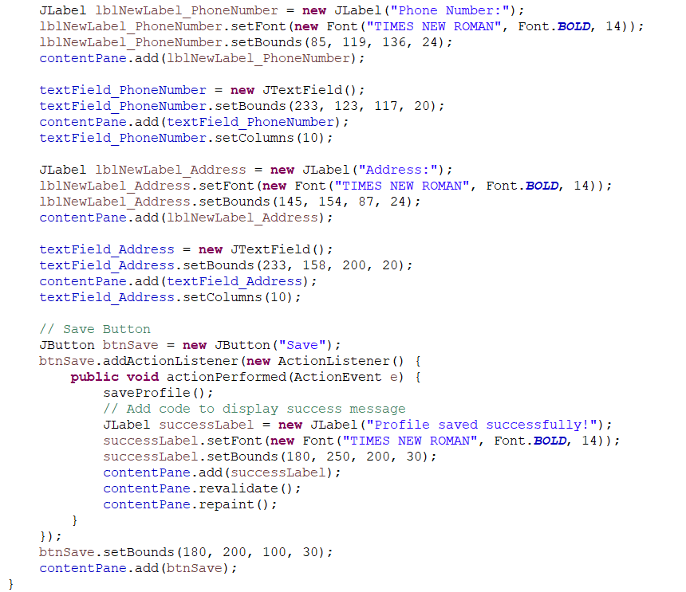

The code supplied uses inheritance, where the `JFrame} class is extended by the `Manage_Personal_Profile_Page` class. {Manage_Personal_Profile_Page} may become a graphical window by inheriting all of `JFrame}'s methods and properties thanks to this inheritance. Several Swing components, such as JLabel, JTextField, and JButton, are added to the window's content pane inside the Manage_Personal_Profile_Page constructor. These components inherit the JFrame methods for component placement and addition. Furthermore, event handling is implemented, whereby the `JButton} class, which is derived from `JFrame}, provides an action listener to control the click event of the "Save" button.

, the username exemplifies how inheritance can significantly enhance functionality.

### 7.6 ABSTRACTION

**private void initComponents() {**

**...**

**}**

The initComponents function simplifies the configuration and initialization of GUI components. This method exemplifies the concept of abstraction by concealing from the application logic the complex GUI setup elements, such as generating components, designating their properties, and adding them to the frame. Users of the Administrator_Account class are not required to comprehend GUI assembly or component initialization in order to utilize the class.

# 8.0 IMPLEMENTATION

## 8.1 ADMINISTRATOR

**CODE:**

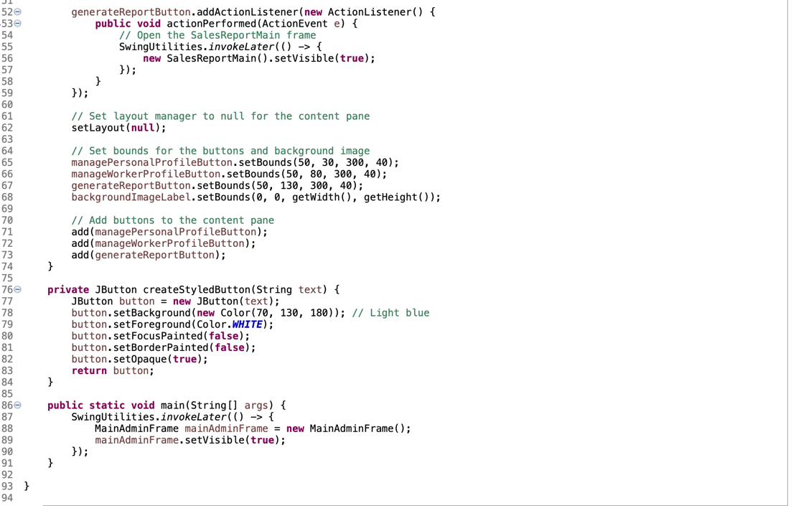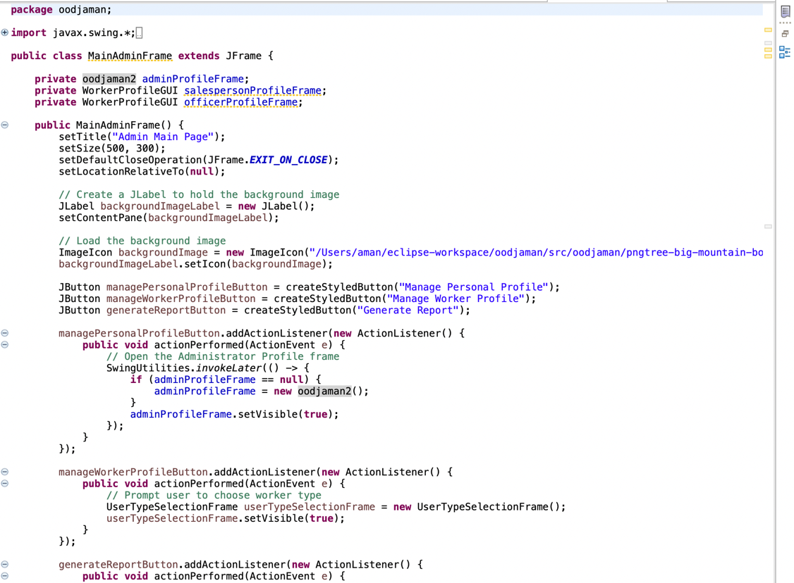

**GUI:**

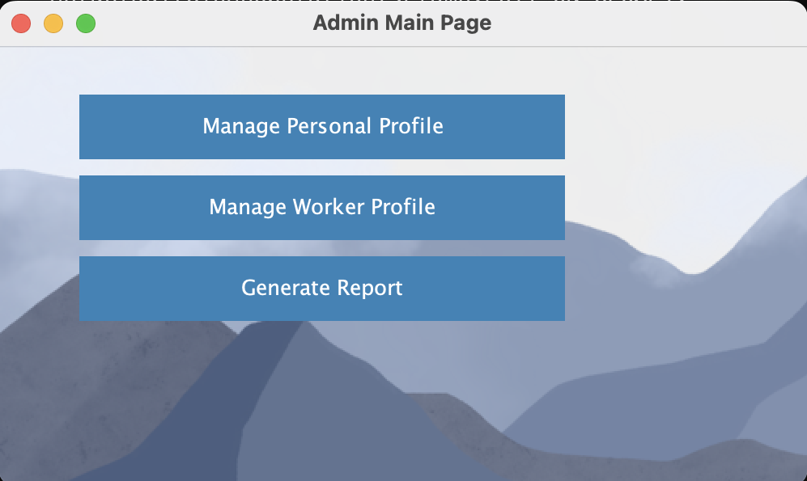

**DESCRIPTION:**

A Java Swing JFrame that expands the capabilities of (GUI) is the MainAdminFrame class. The application's entry point is the public static void main function. The frame's position, size, closure operation, and title are all set inside the constructor. It uses an ImageIcon to load the background picture and configures styled buttons with action listeners. The content pane is set using the setContentPane function, and layout management is turned off by using setLayout(null), which permits component placement by hand. Lastly, the MainAdminFrame object is created and made visible by the main function, which then starts the GUI.

**CODE:**

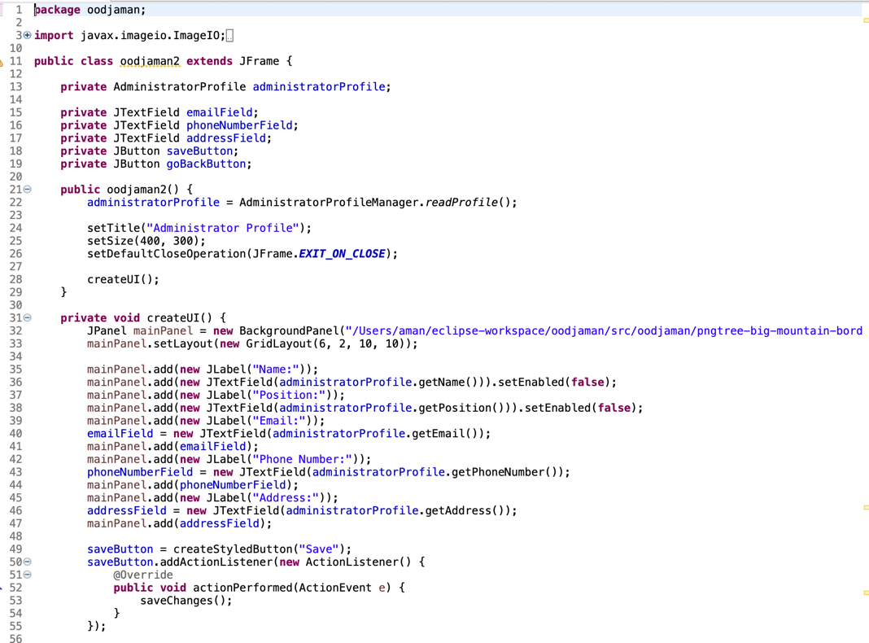

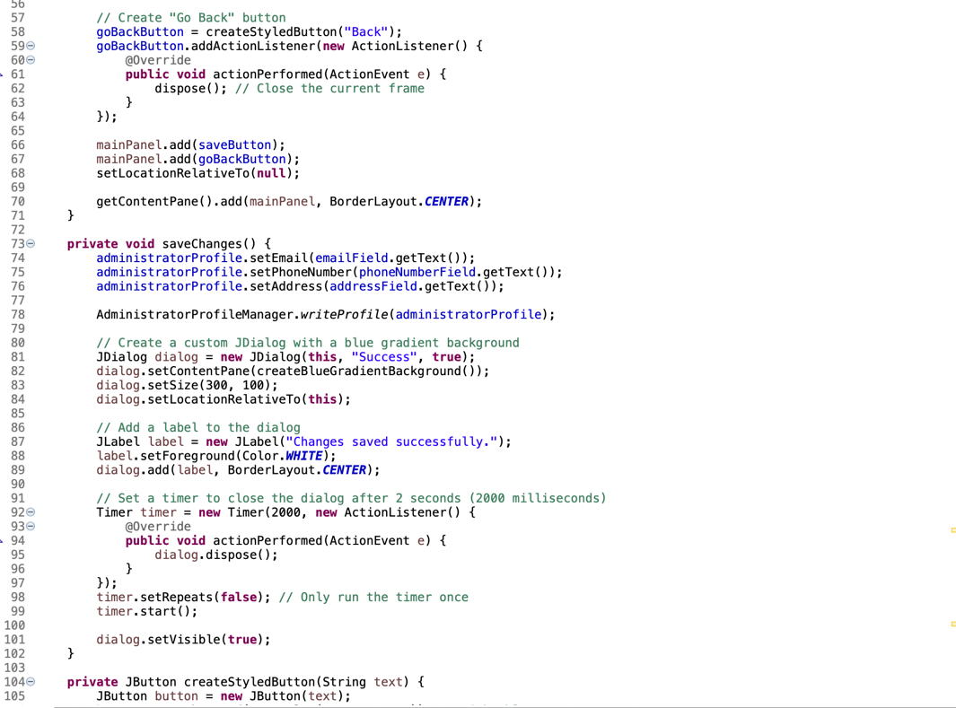

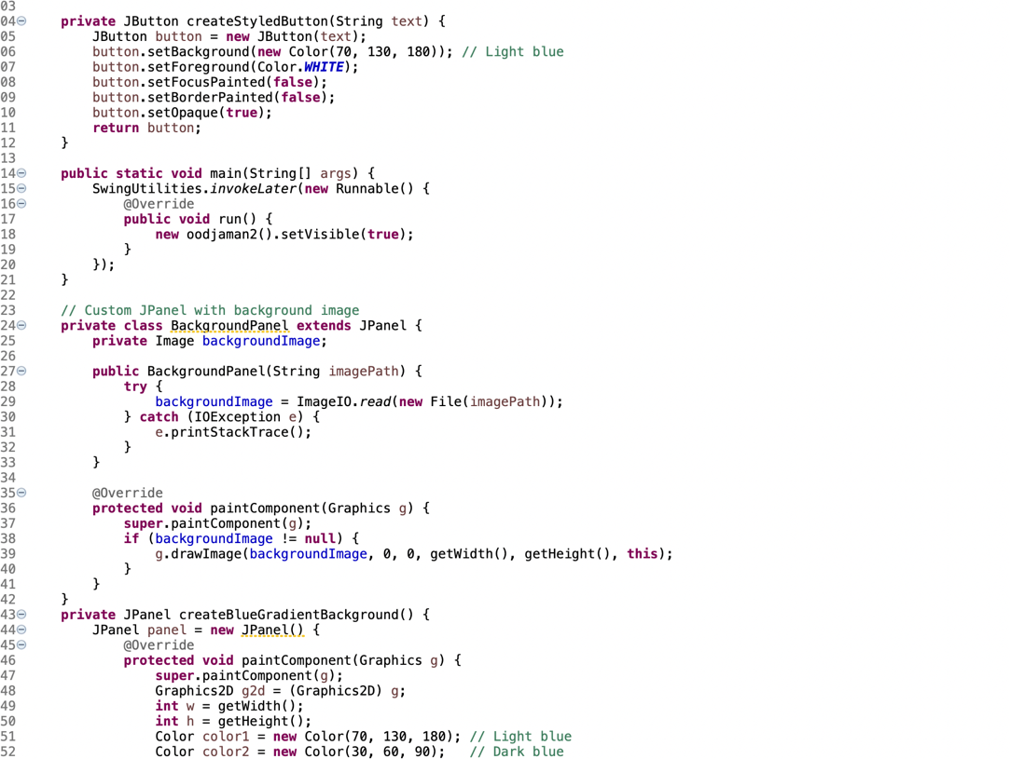

**GUI:**

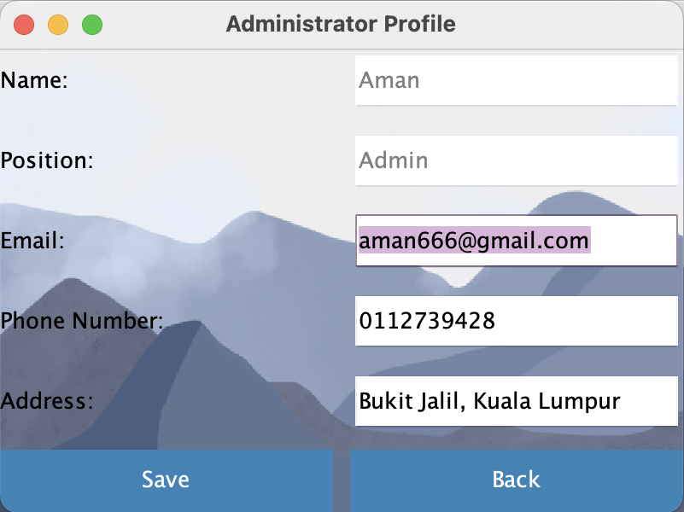

**DESCRIPTION:**

A Swing `JFrame} that manages the Administrator Profile is the `oodjaman2} class. It has areas where you may examine and edit details. The `saveChanges` method modifies the profile, opens a feedback box with a backdrop gradient of blue, and closes on its own after two seconds. The user interface (UI) makes use of Swing components, and the buttons ({saveButton} and `goBackButton{) have been given a unique light blue style with white text to make them visually appealing.

**CODE:**

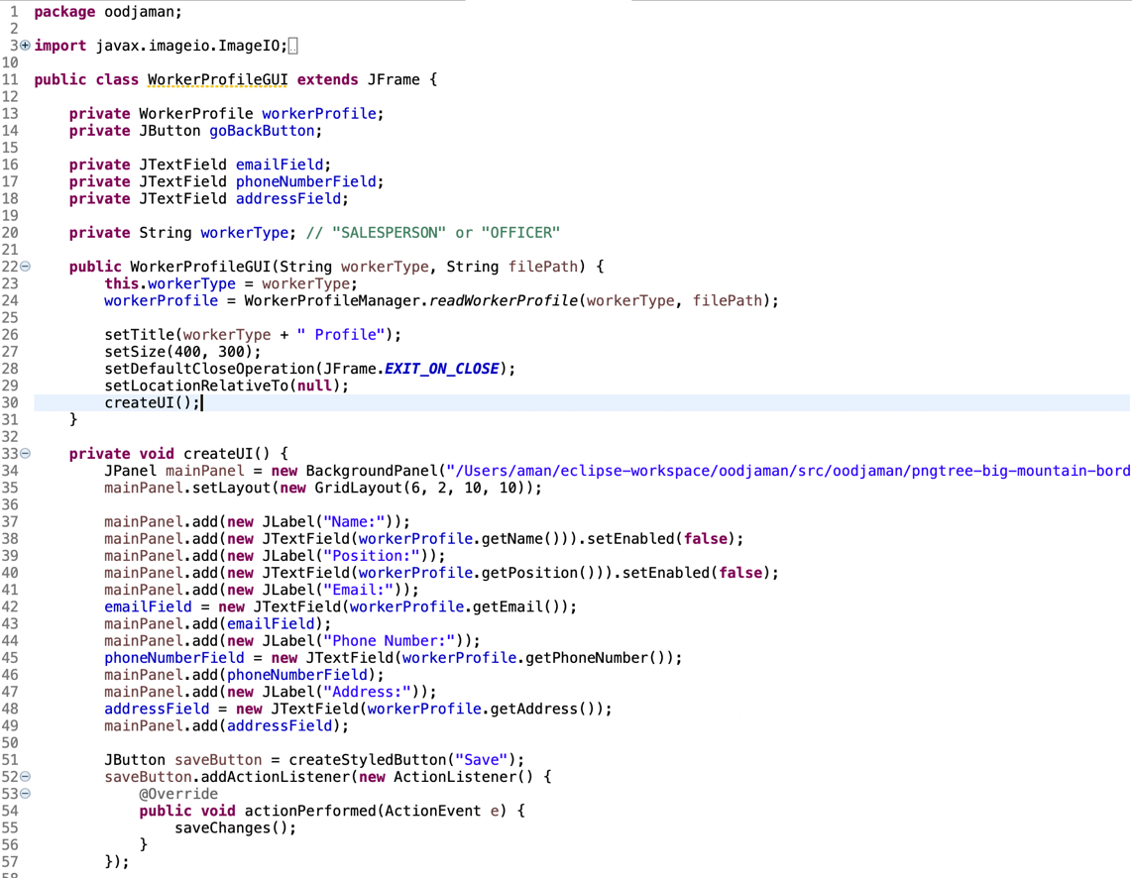

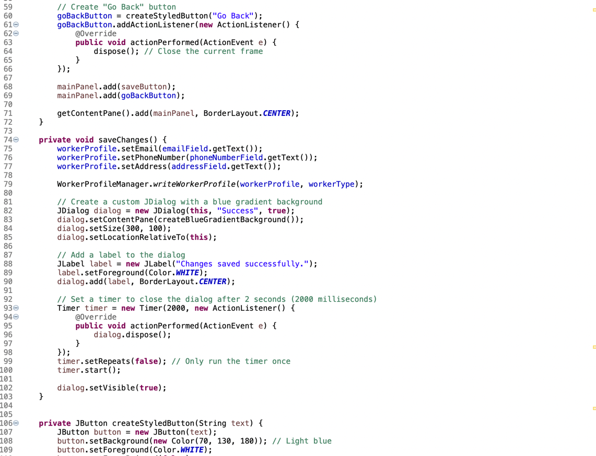

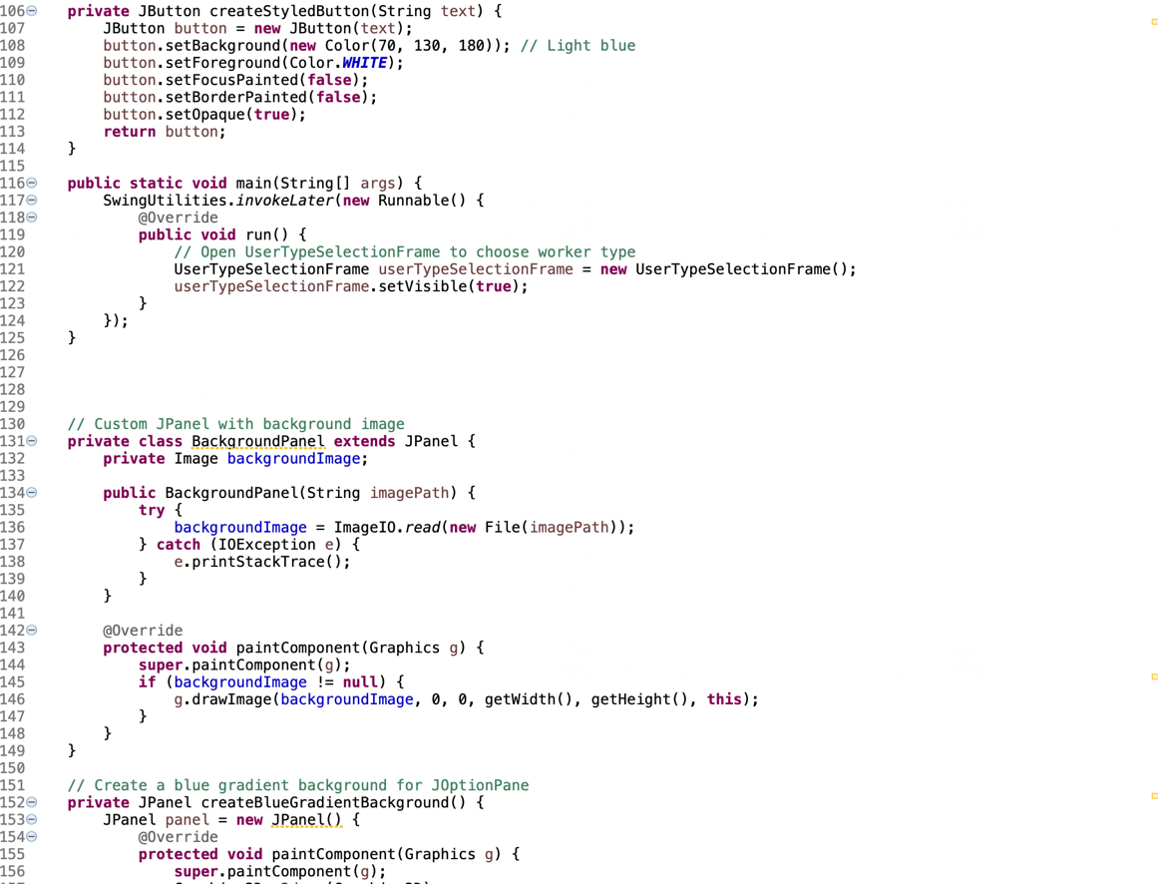

**GUI:**

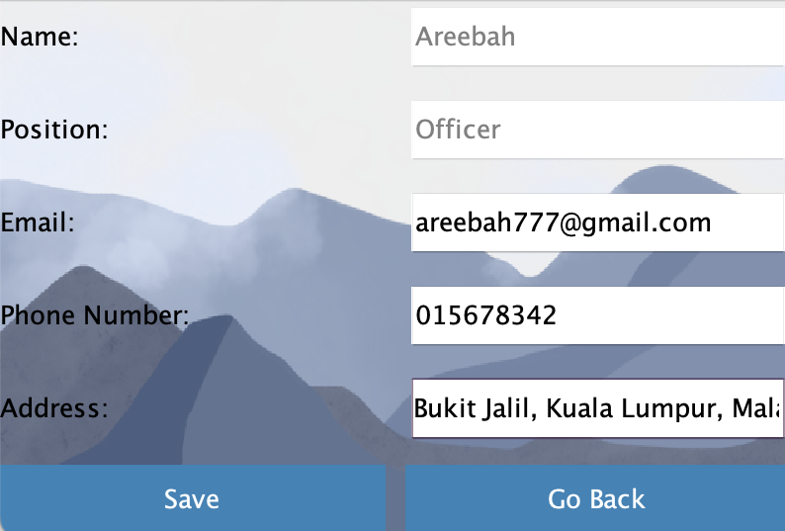

**DESCRIPTION:**

The WorkerProfileGUI class uses Swing to provide a graphical user interface for controlling worker profiles. It extends JFrame, uses numerous Swing components (such as JPanel and JButton), and handles events via ActionListener. It has layout control, file I/O for worker profiles, and a customizable BackgroundPanel for background pictures. The GUI allows users to change and save worker information while receiving visible feedback via a success dialog.

**CODE:**

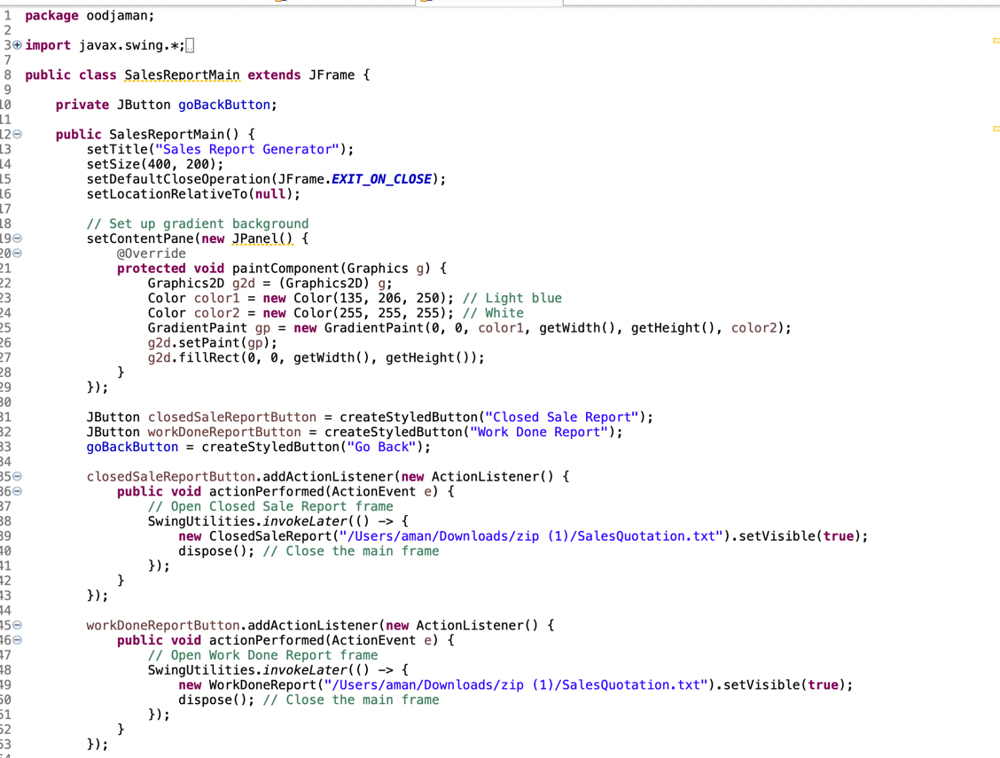

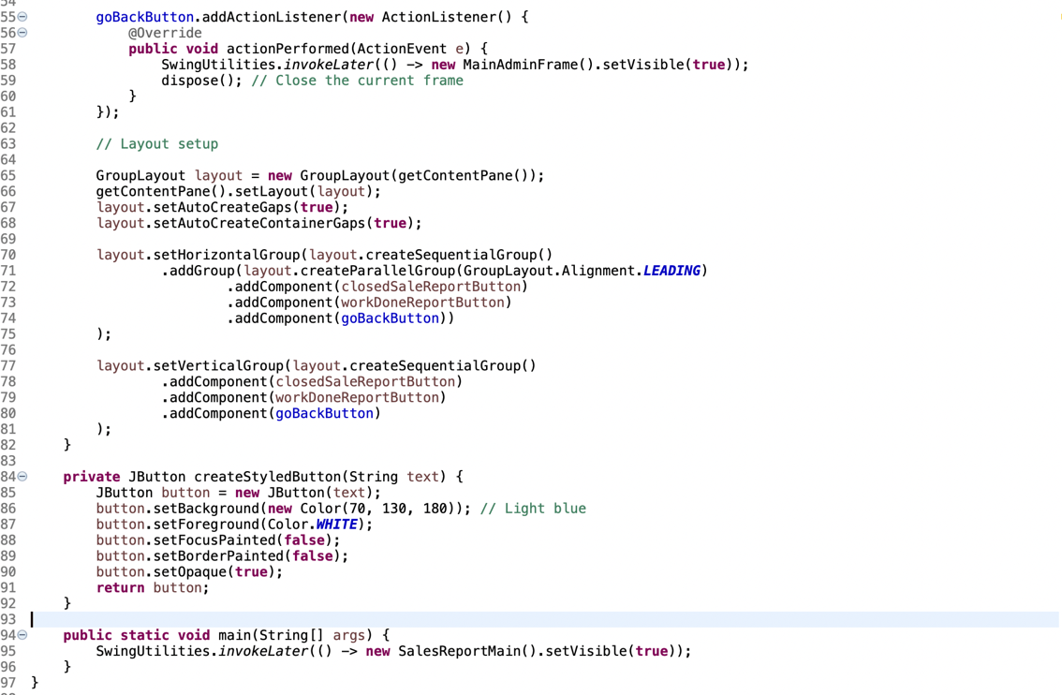

**GUI:**

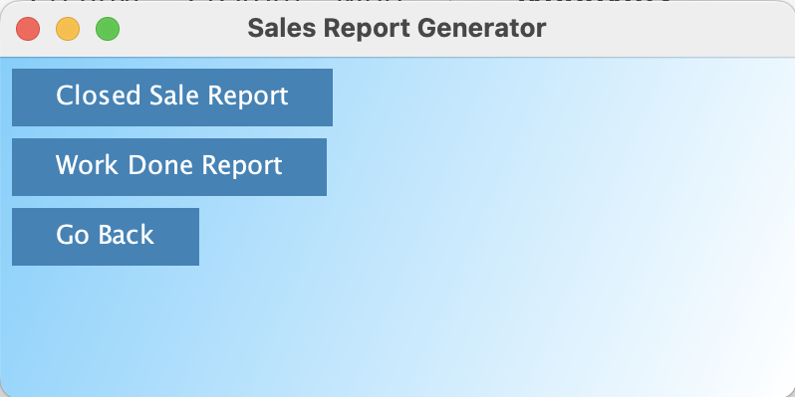

**DESCRIPTION:**

The 'SalesReportMain' class manages its layout using GroupLayout, and the 'createStyledButton' function is used to make styled buttons. The buttons ("Closed Sale Report," "Work Done Report," and "Go Back") have matching listeners, which use SwingUtilities for thread safety. When clicked, the "Closed Sale Report" and "Work Done Report" buttons open other frames ('ClosedSaleReport' and 'WorkDoneReport', respectively), while the "Go Back" button returns to the 'MainAdminFrame'. The design attempts to provide a visually appealing and responsive sales report generation interface.

**CODE:**

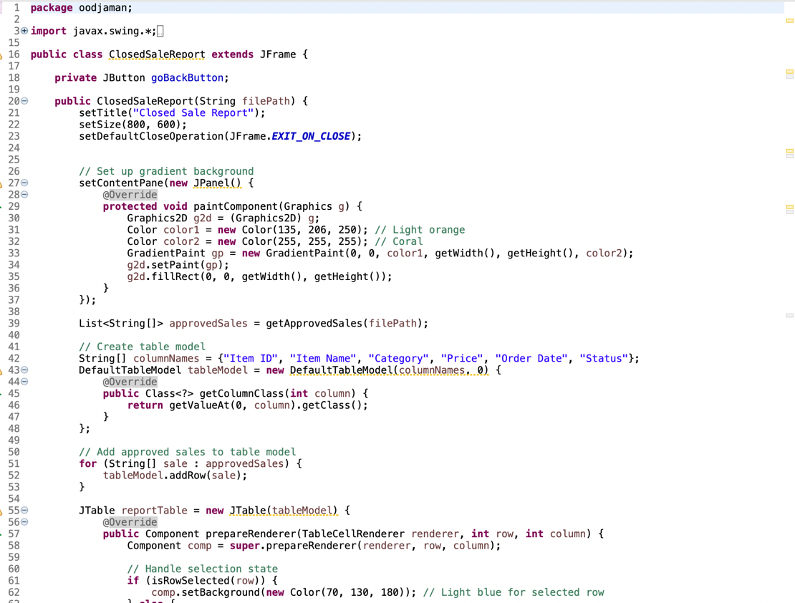

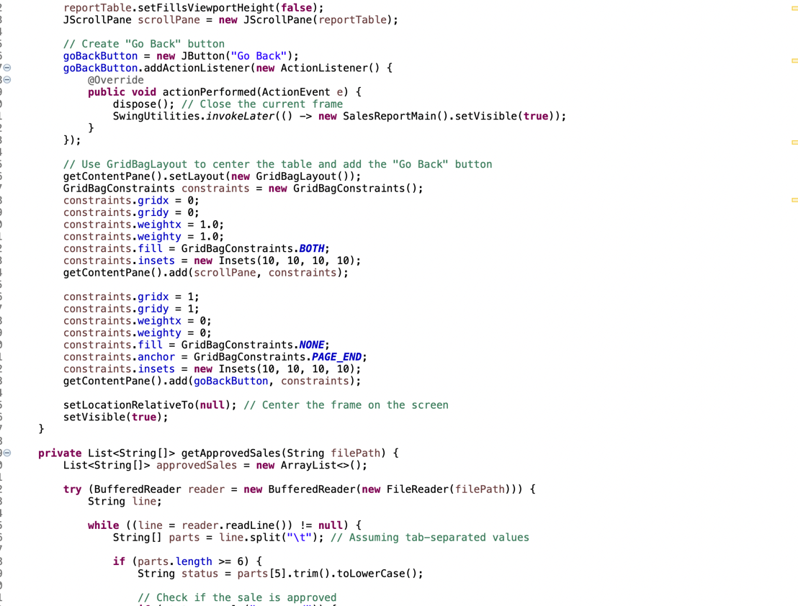

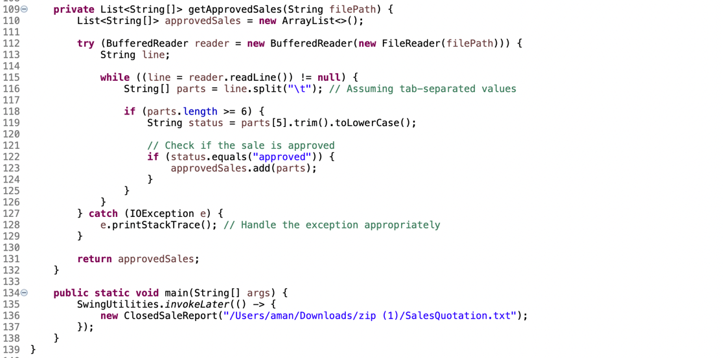

**GUI:**

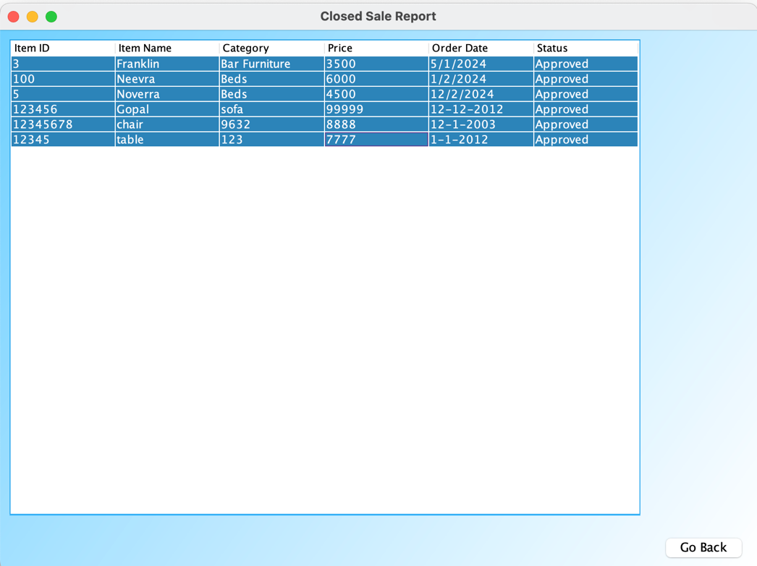

**DESCRIPTION:**

The ClosedSaleReport class uses Swing for its GUI, which includes a JTable displaying authorized sales data and a gradient backdrop. By using SwingUtilities.By managing GUI activities on the Event Dispatch Thread (EDT), invokeLater in the main function guarantees thread safety. The class changes the JTable dynamically after reading sales data from a file and removing authorized sales. The "Go Back" button returns to the sales report's main frame with ease. The program uses a GridBagLayout to keep its layout tidy and aesthetically pleasing. In order to mitigate any concurrent concerns, it is imperative that invokeLater be used to ensure that Swing components are generated and changed on the EDT.

**CODE:**

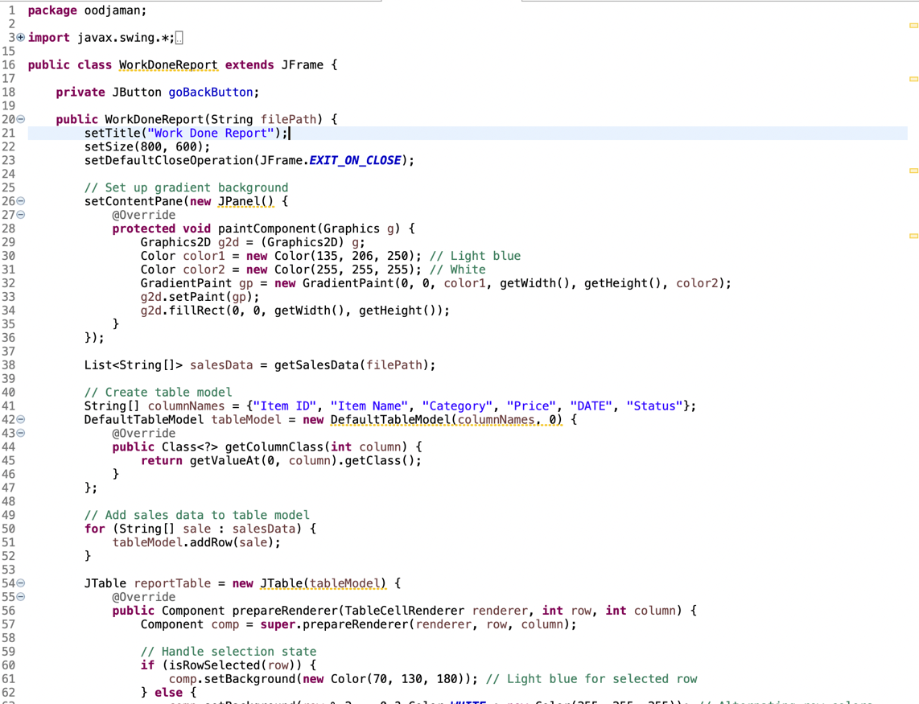

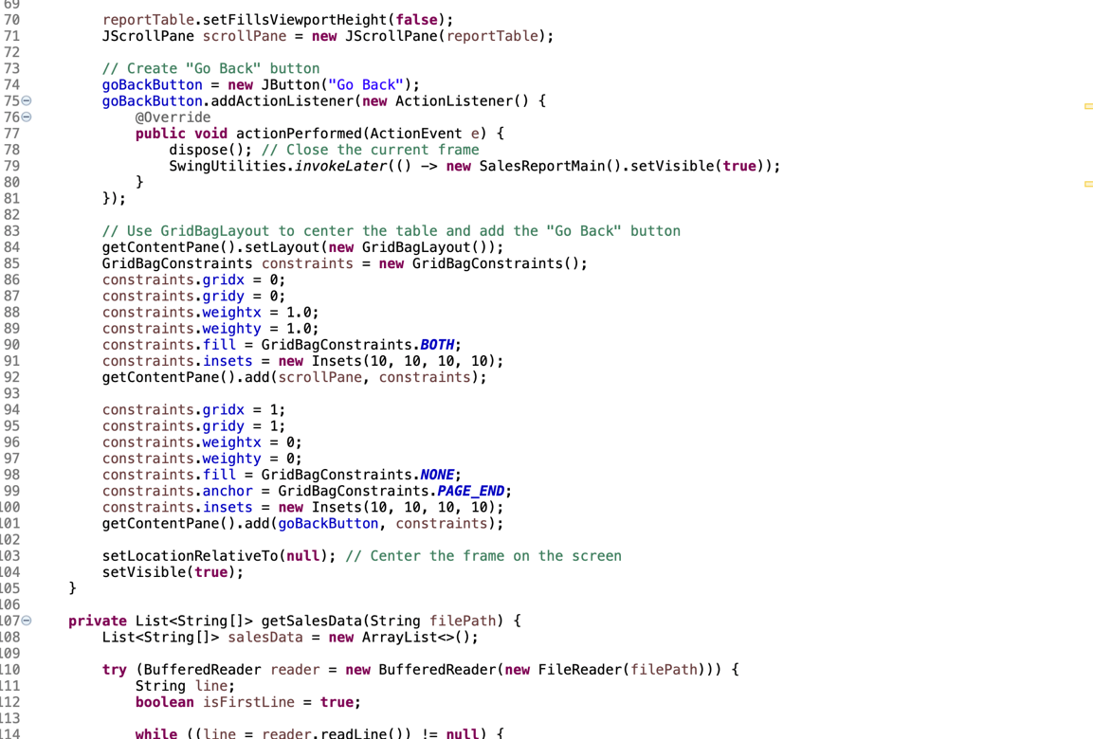

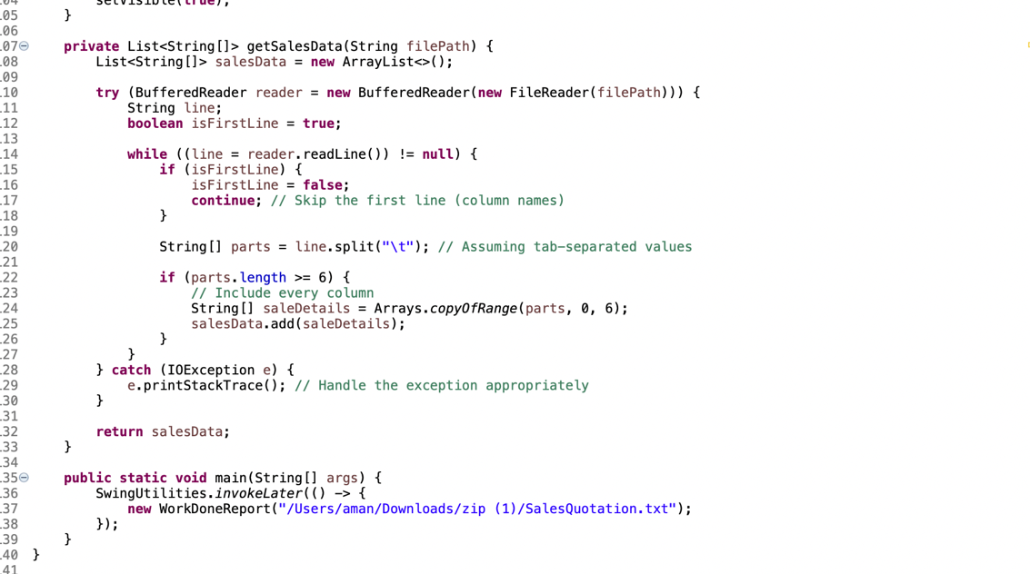

**GUI:**

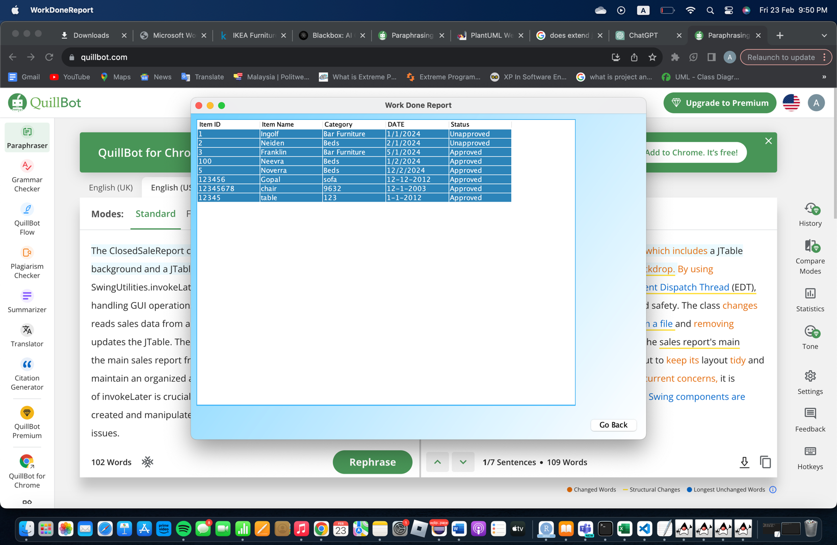

**DESCRIPTION:**

Swing is used in the WorkDoneReport class to provide a modern GUI with a gradient backdrop and a dynamic JTable for sales data. Using SwingUtilities.Thread safety is ensured with invokeLater. The "Go Back" button seamlessly returns to the main sales report, and the parsing algorithm filters and shows sales information. A balanced visual layout is orchestrated by the GridBagLayout.

## 8.2 SALESPERSON

**CODE:**

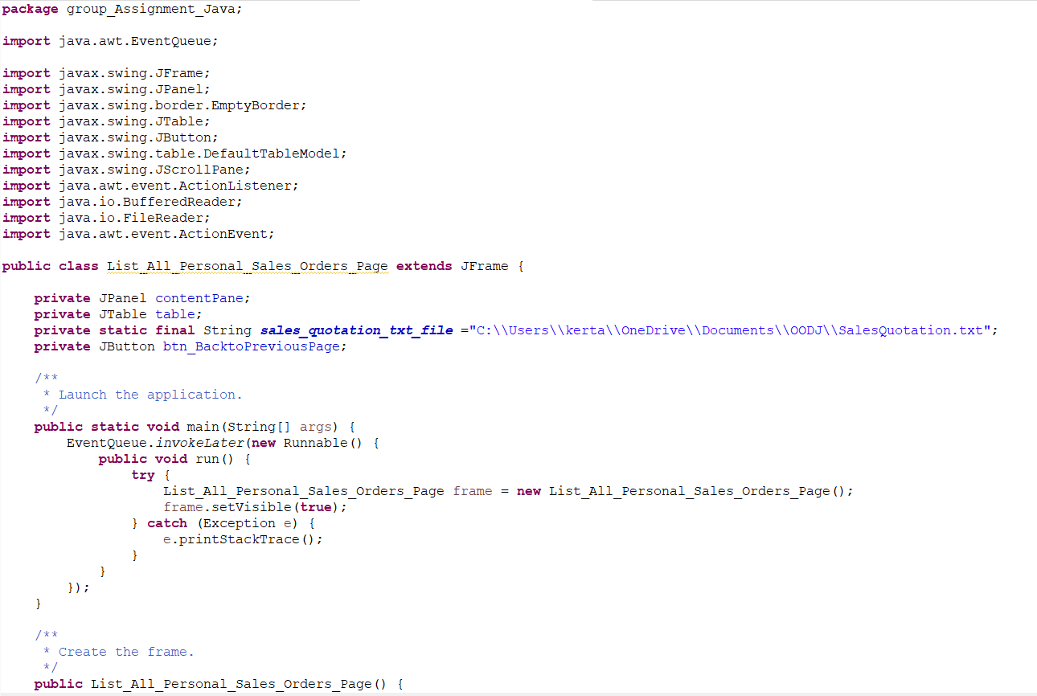

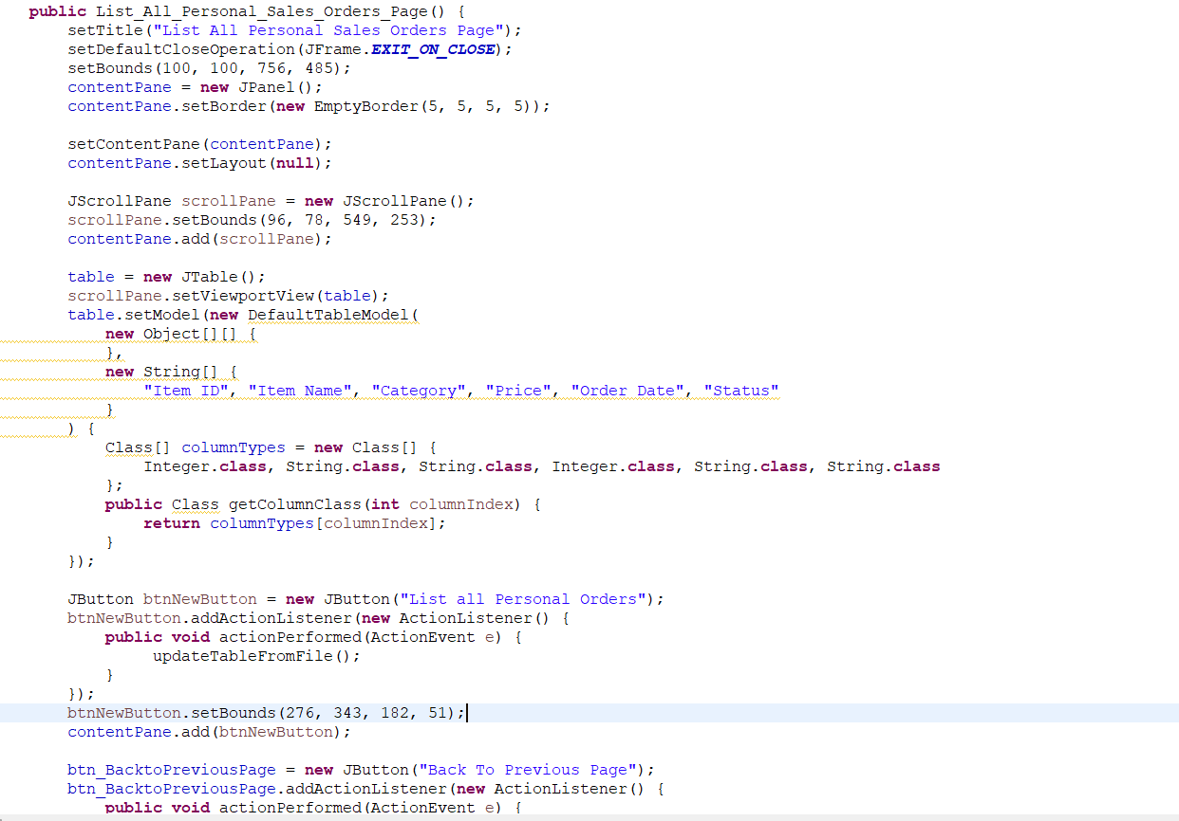

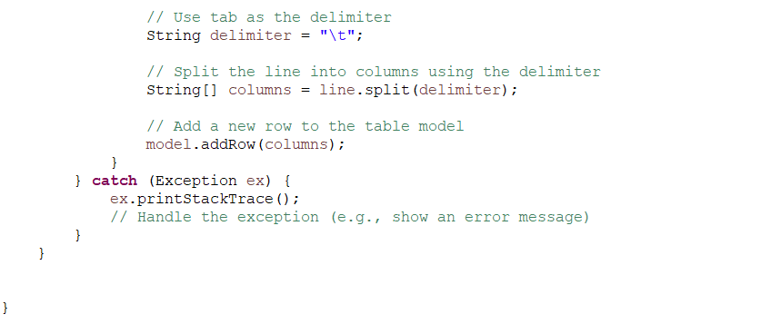

**GUI:**

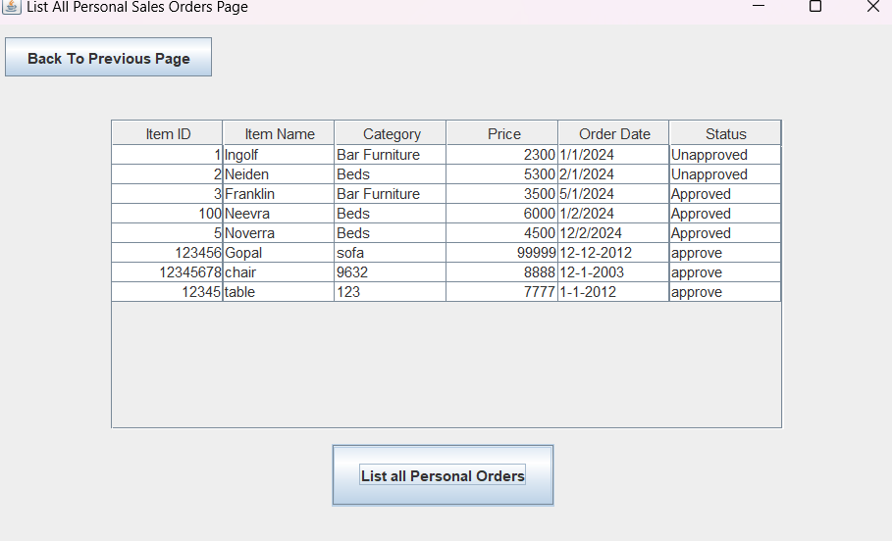

The figure above shows the listing of all the orders. It contains of Item ID, Item Name, Category, Price, Order Date and Status.

**CODE:**

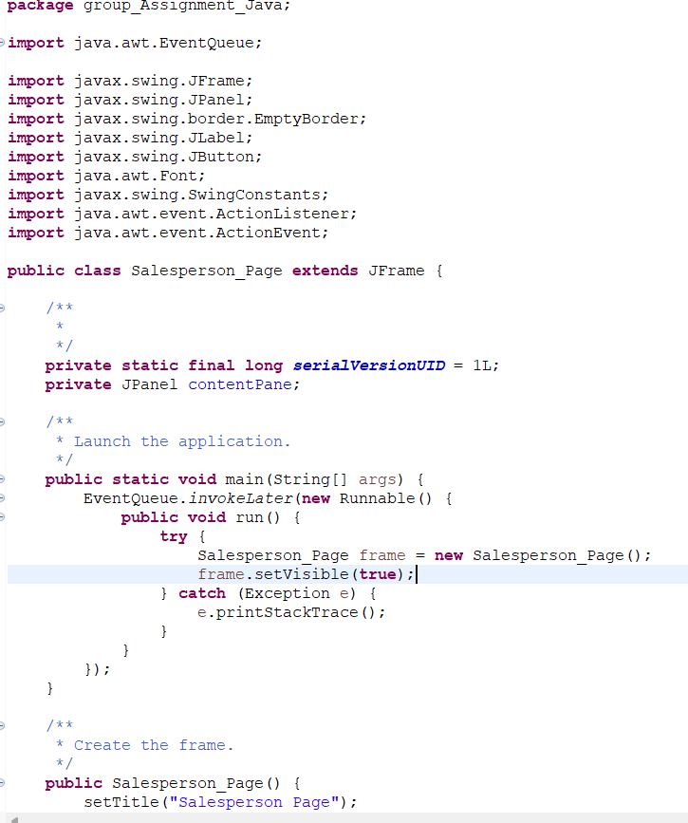  
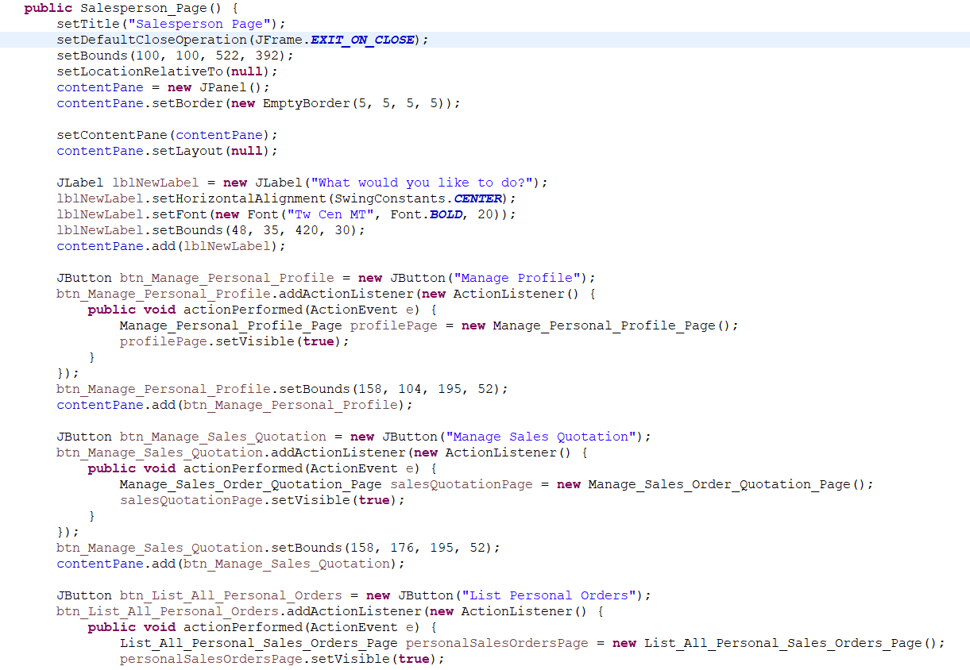

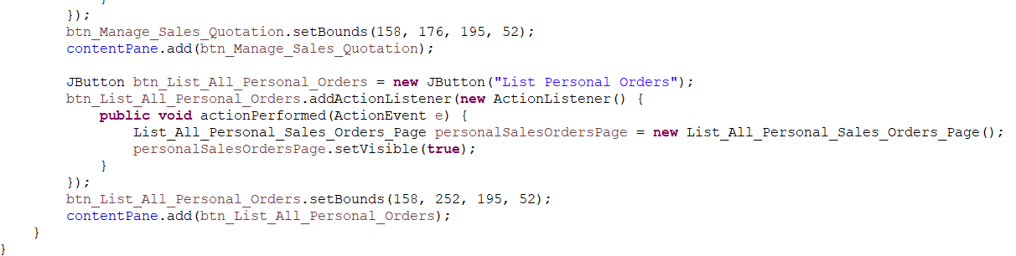

**GUI:**

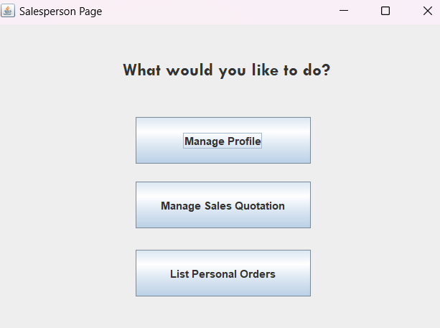  
  
The figure above shows the main page of a salesperson. The page contains of Manage Profile, Manage Sales Quotation and Listings of Personal Orders.

**CODE:**

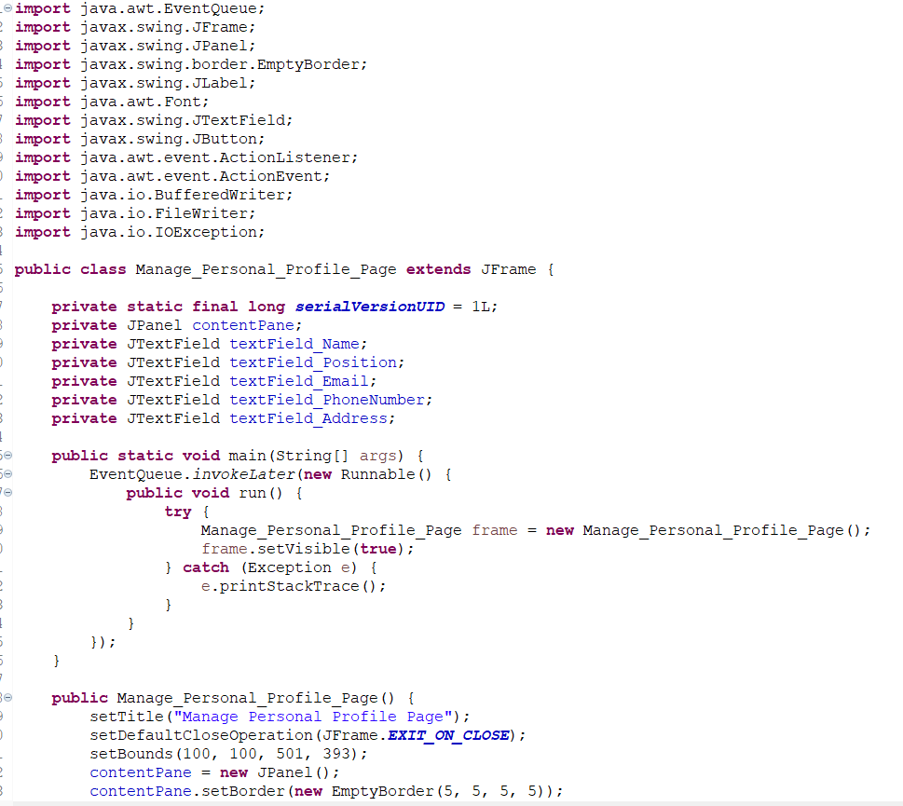

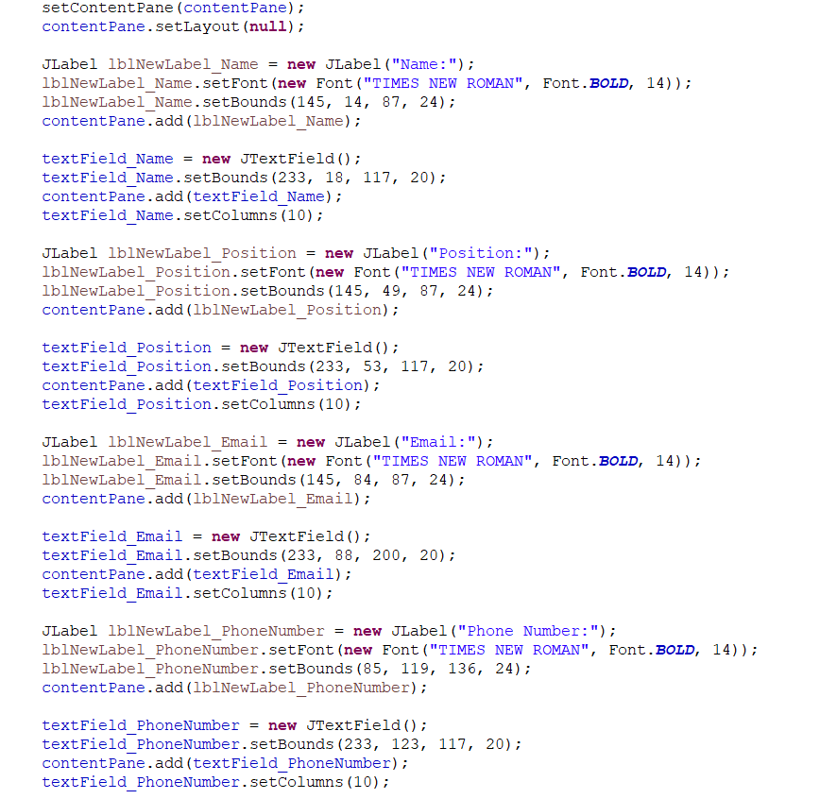



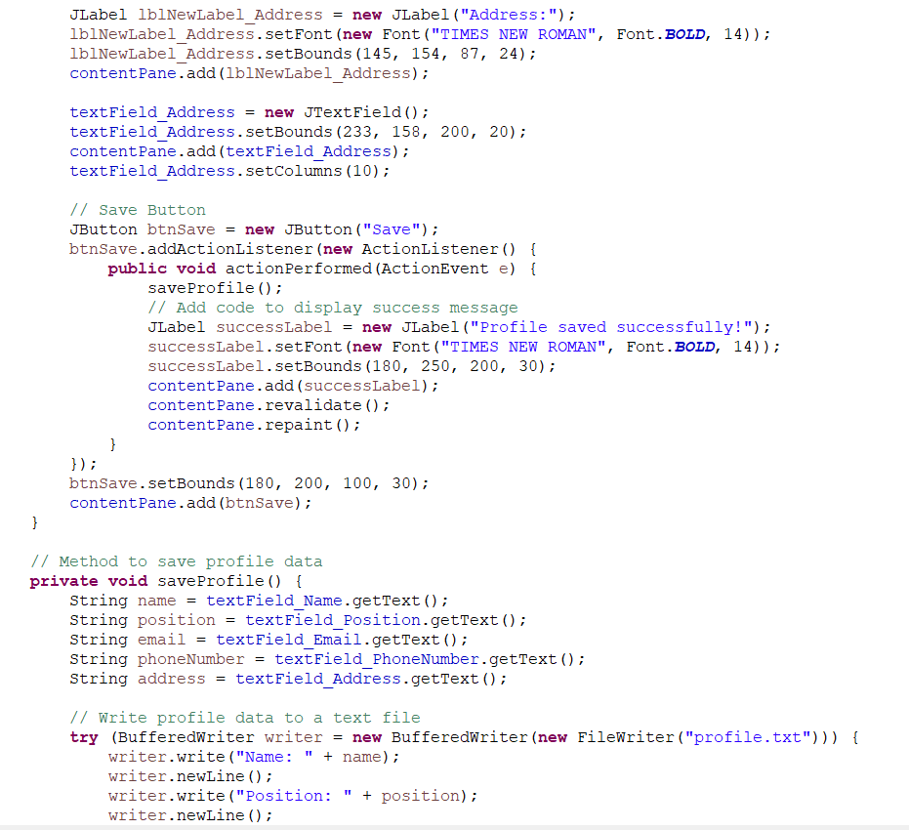

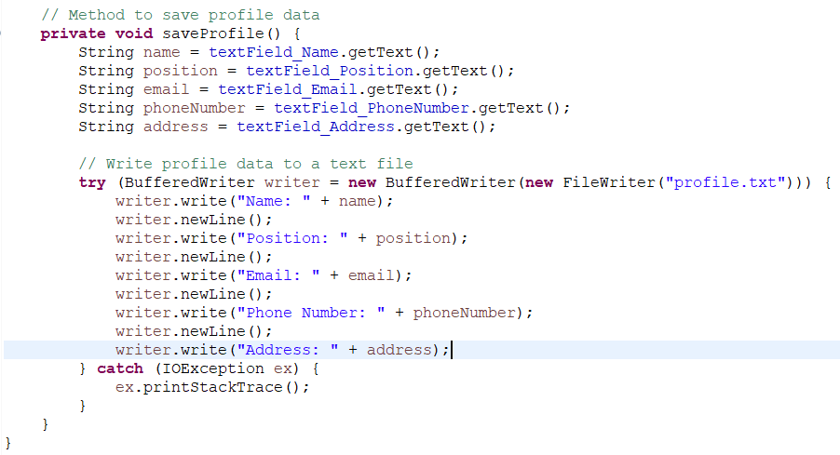

**GUI:**

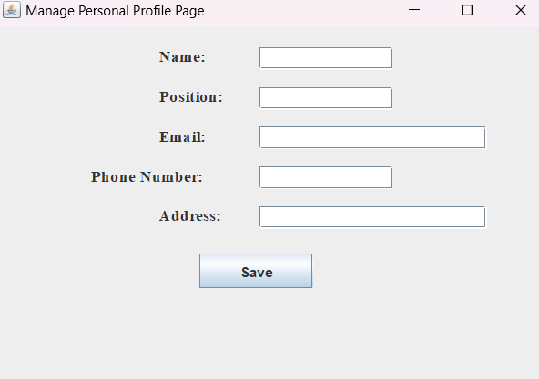  
The figure above shows the Personal Profile page. The page includes Name, Position, Email, Phone Number and Address. 

**CODE:**

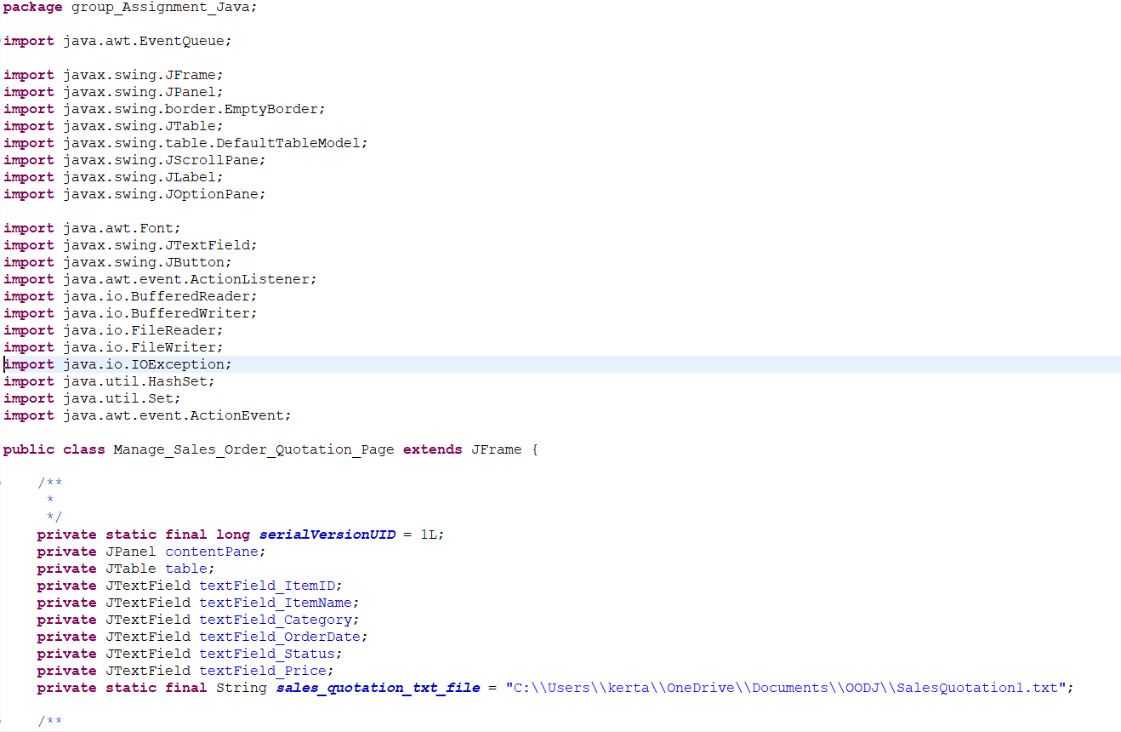

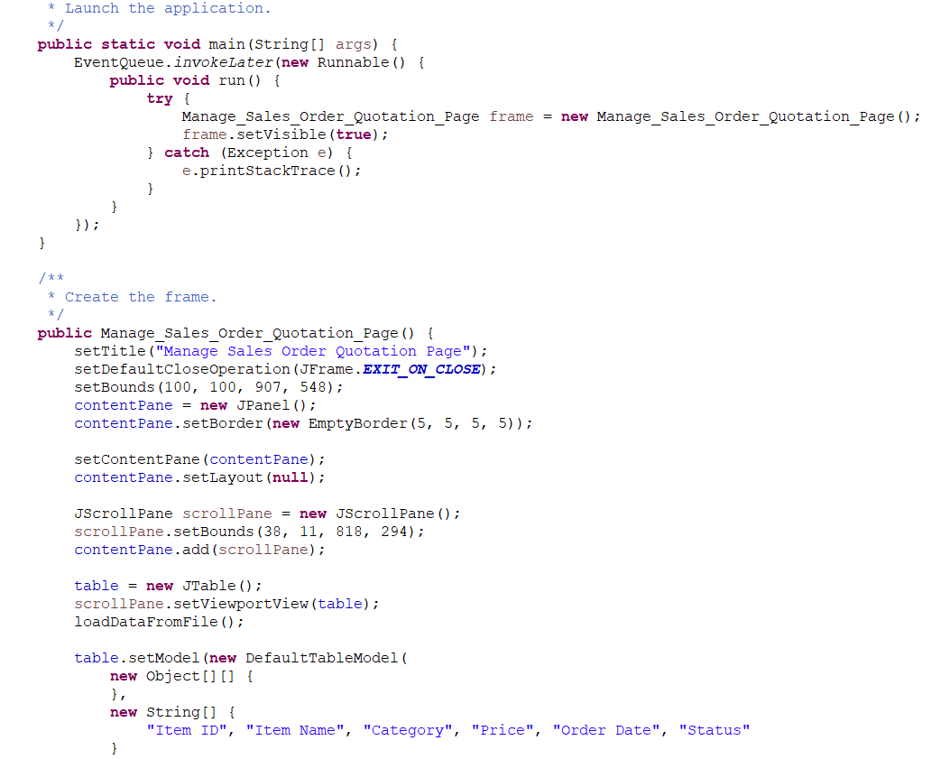

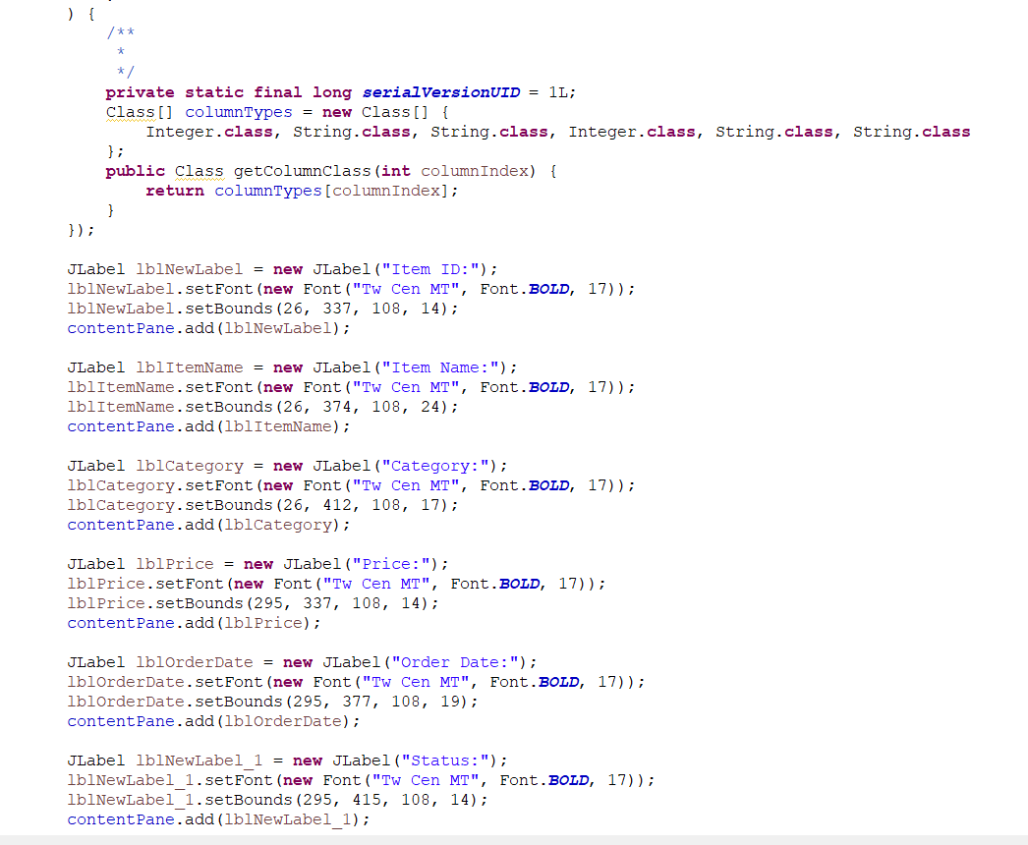

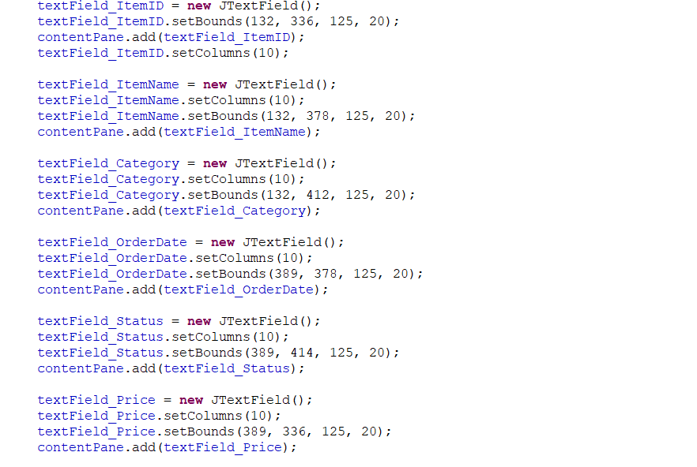

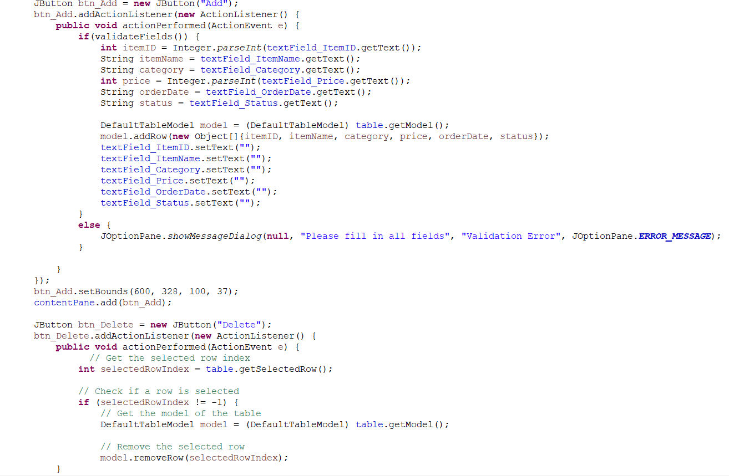

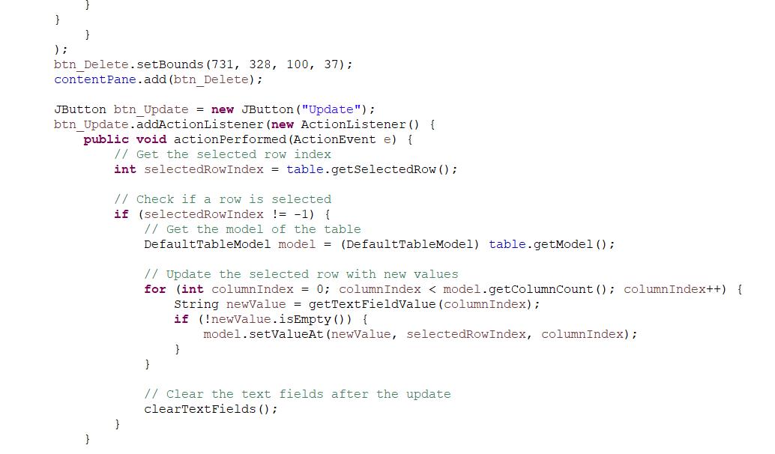

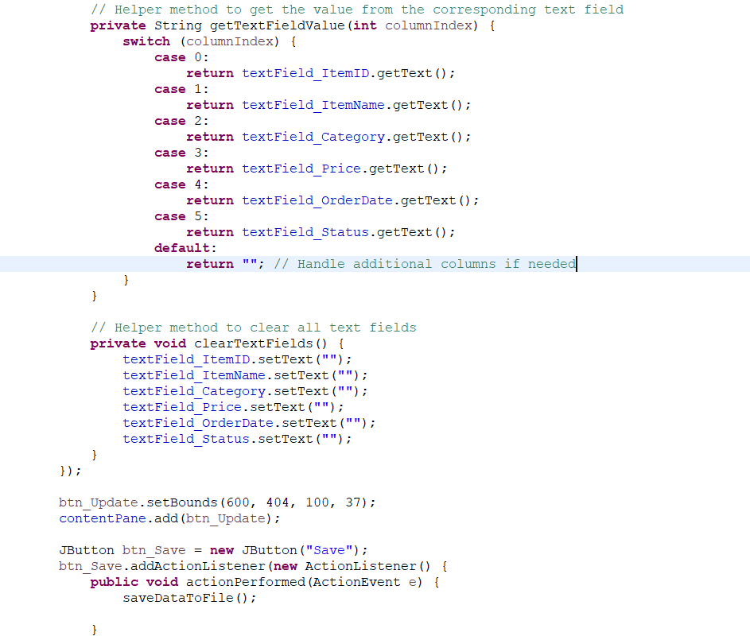

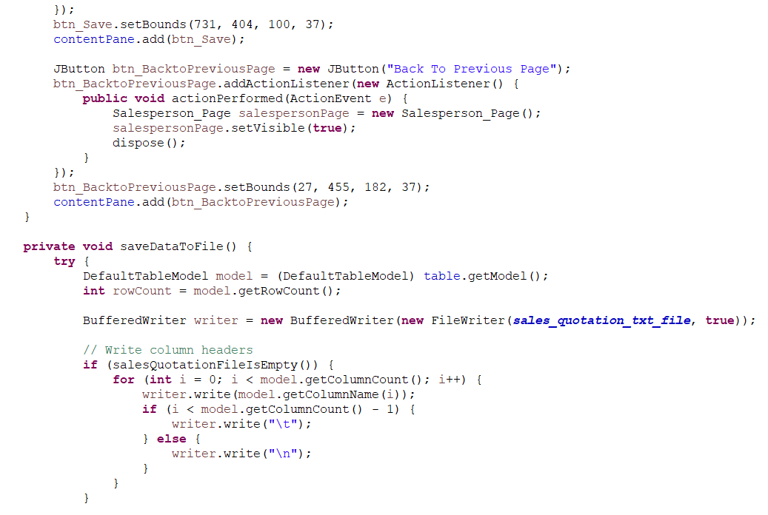

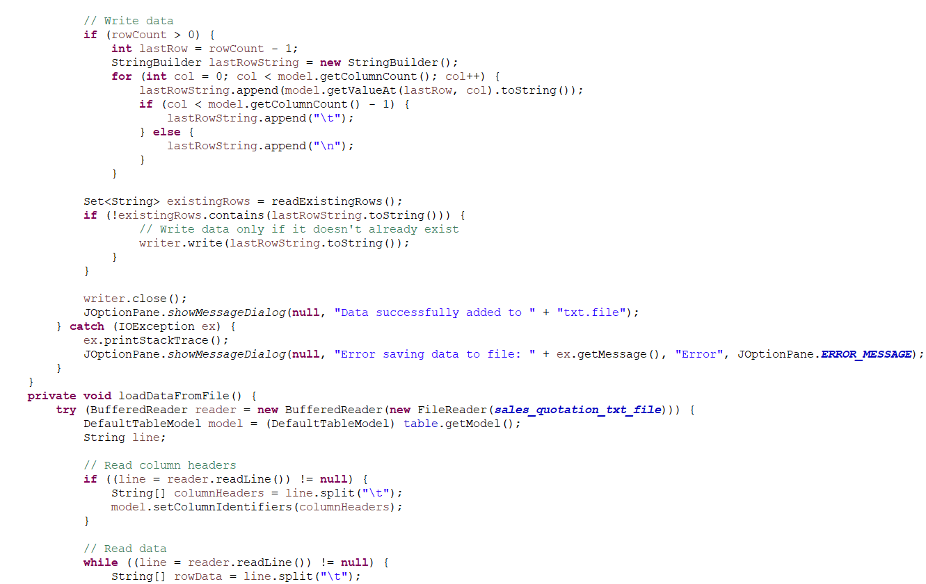

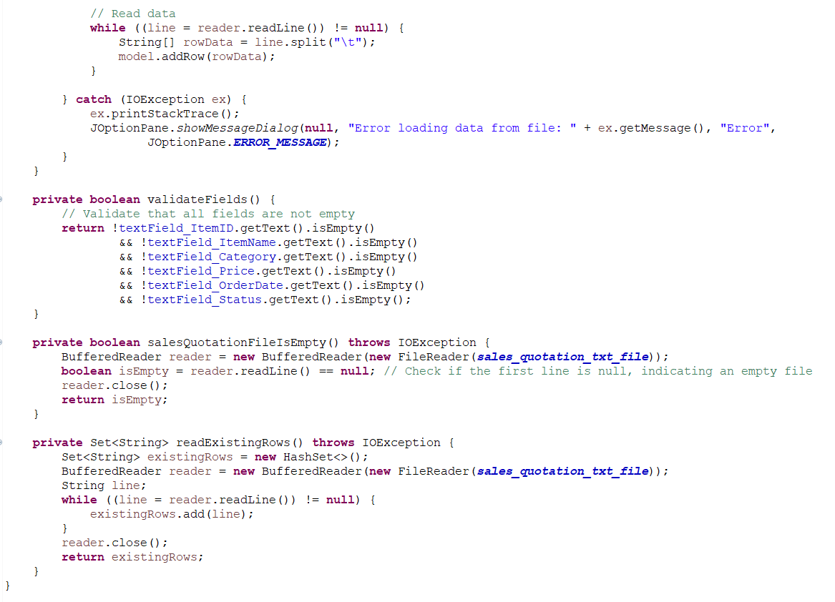

**GUI:**

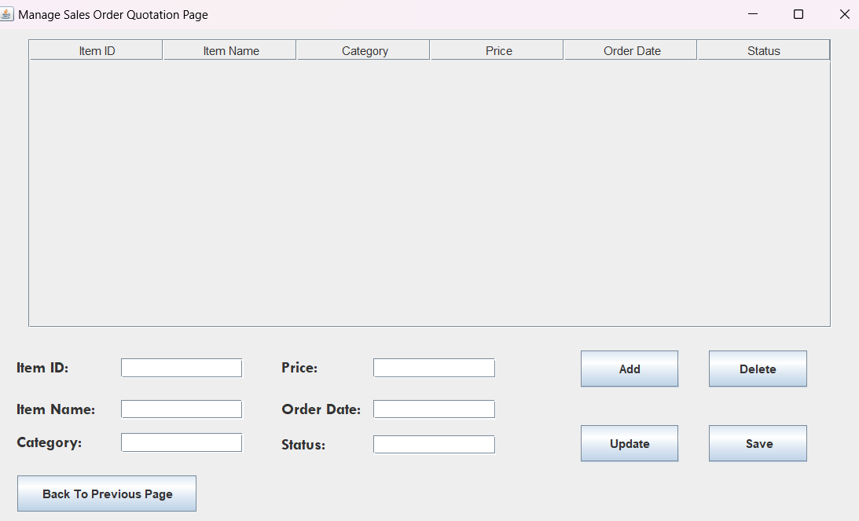

The figure above shows the page to manage sales order quotation. The page above shows the field to put in the details. 

## 8.3 OFFICER

**CODE:**

**Officer class:**

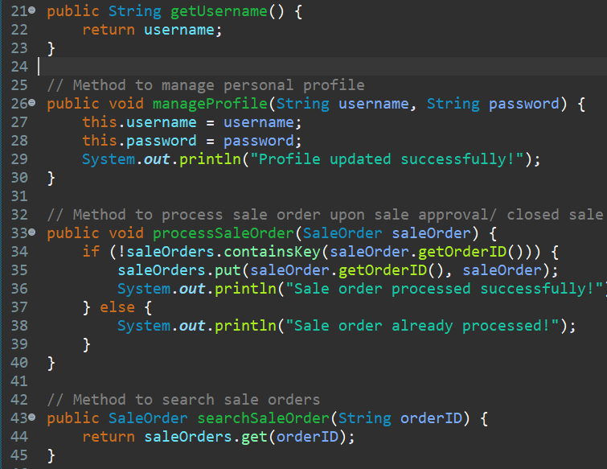

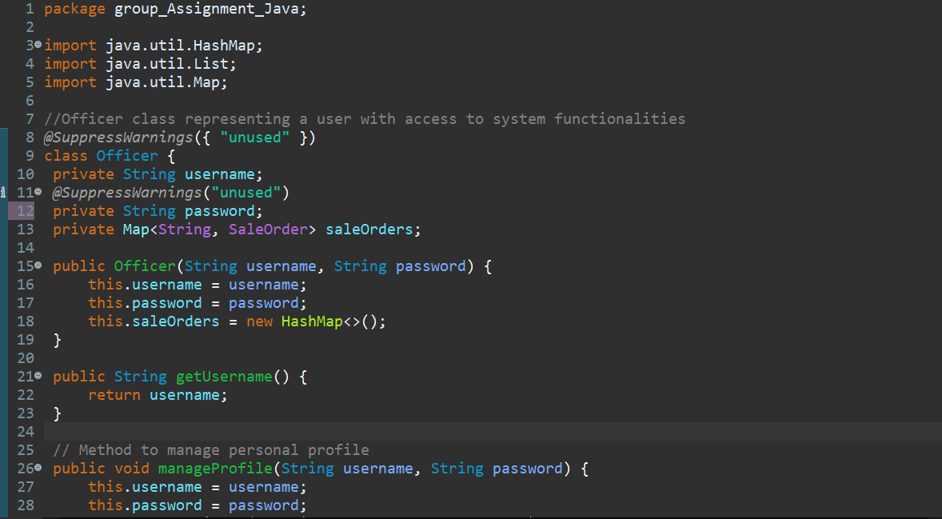

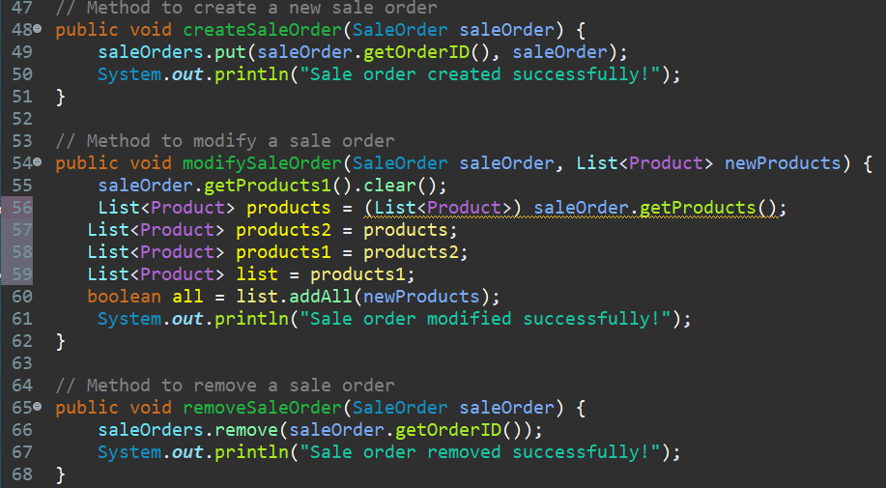

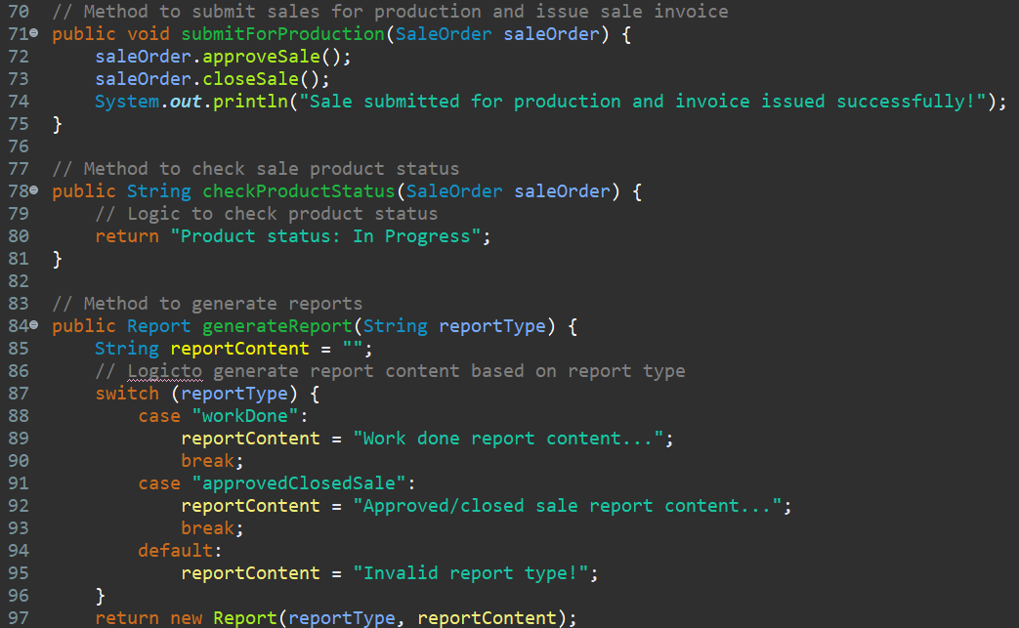

The `Officer` class in the provided code serves as a representation of a user within a system, specifically focusing on their role in managing sale orders and generating reports. The class uses encapsulation to store and manipulate relevant data, such as the officer's username and password, as private instance variables. The `saleOrders` variable, implemented as a `Map`, allows efficient storage and retrieval of sale orders based on their unique order IDs. The class provides several methods to interact with sale orders. The `processSaleOrder` method adds a sale order to the `saleOrders` map if it doesn't already exist, and the `createSaleOrder` method adds a new sale order to the map. Conversely, the `removeSaleOrder` method removes a sale order from the map. The `modifySaleOrder` method enables the modification of a sale order by replacing its existing list of products with a new list.Other methods focus on different aspects of sale order management. The `searchSaleOrder` method allows searching for a specific sale order based on its order ID. The `submitForProduction` method initiates the process of approving and closing a sale order, while the `checkProductStatus` method is intended to provide information about the status of the products within a sale order. Additionally, the `Officer` class includes functionality to manage personal profiles. The `manageProfile` method allows an officer to update their username and password. Lastly, the `generateReport` method generates reports based on a specified report type. The method uses a `switch` statement to determine the content of the report based on the provided type. Currently, two report types, "workDone" and "approvedClosedSale," are supported, each with its corresponding report content. If an invalid report type is provided, a default message is assigned.

**Product class:**

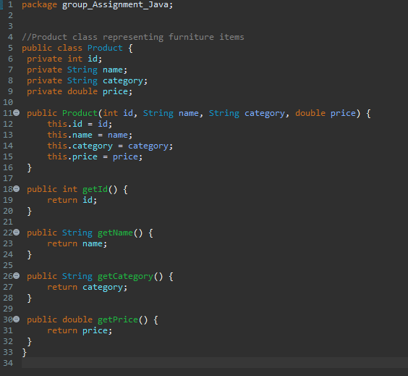

 The provided code defines a `Product` class representing furniture items. This class encapsulates the properties of a product, including its ID, name, category, and price. The class has a constructor that takes these properties as parameters and assigns them to the corresponding instance variables. Additionally, the class provides getter methods for each property, allowing other classes to retrieve the values of the product's ID, name, category, and price. Overall, the `Product` class serves as a blueprint for creating instances of furniture products and accessing their information when needed.

**Invoice class:**

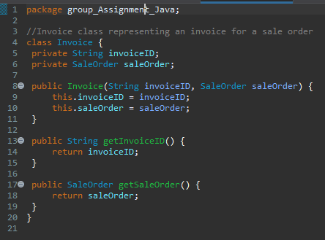

The provided code introduces the `Invoice` class, representing an invoice for a sale order. This class encapsulates the properties of an invoice, including the invoice ID and the corresponding sale order. The `Invoice` class has a constructor that takes the invoice ID and the associated sale order as parameters and initializes the respective instance variables. It also provides getter methods to retrieve the invoice ID and the sale order. The `Invoice` class serves as a blueprint for creating invoice objects that store information about a specific sale order, enabling easy access to the invoice details when needed.

**Report class:**

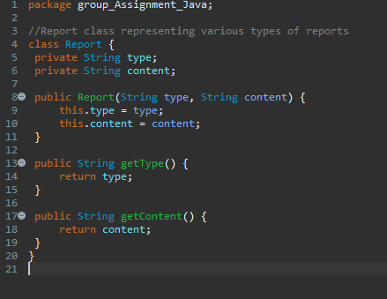

The provided code introduces the `Report` class, which represents various types of reports. This class encapsulates two properties: the type of the report and its corresponding content. The `Report` class includes a constructor that takes the report type and content as parameters and initializes the respective instance variables. It also provides getter methods to retrieve the report type and content. The `Report` class serves as a blueprint for creating report objects with specific types and content, allowing easy access to these details when generating or working with reports in a system.

**SaleOrder class:**

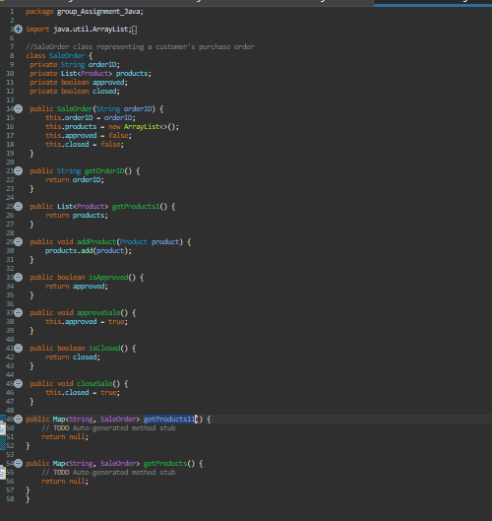

The provided code presents the `SaleOrder` class, representing a customer's purchase order. This class encapsulates the properties of a sale order, including the order ID, a list of products, and the status of approval and closure. The `SaleOrder` class features a constructor that takes the order ID as a parameter and initializes the instance variables. It also provides getter methods to retrieve the order ID, the list of products, and the status of approval and closure. Additionally, there are methods to add a product to the order, approve the sale, and close the sale. The `SaleOrder` class serves as a blueprint for creating sale order objects, allowing easy access to the order details and enabling operations such as adding products, approving the sale, and closing the sale within a system.

**YoyoFurnitureGUI1 class:**

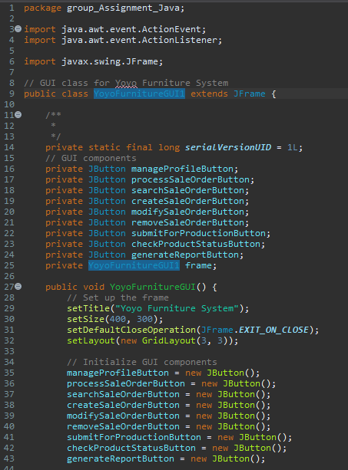

The provided code introduces the `YoyoFurnitureGUI1` class, which represents a graphical user interface (GUI) for the Yoyo Furniture System. This class extends the `JFrame` class from the Swing library, enabling the creation of a window-based interface. The GUI consists of several buttons, each representing a specific functionality within the furniture system. These buttons include options such as managing profiles, processing sale orders, searching sale orders, creating sale orders, modifying sale orders, removing sale orders, submitting orders for production, checking product status, and generating reports. Each button is associated with an action listener, implemented as an anonymous inner class. When a button is clicked, the corresponding action is triggered, and the associated code block is executed. This allows for the customization of functionality and the implementation of specific logic for each button. The GUI components are added to the frame using the `add()` method,

## 8.4 AUTHORIZATION AND AUTHENTICATION

**Administrator_Account**

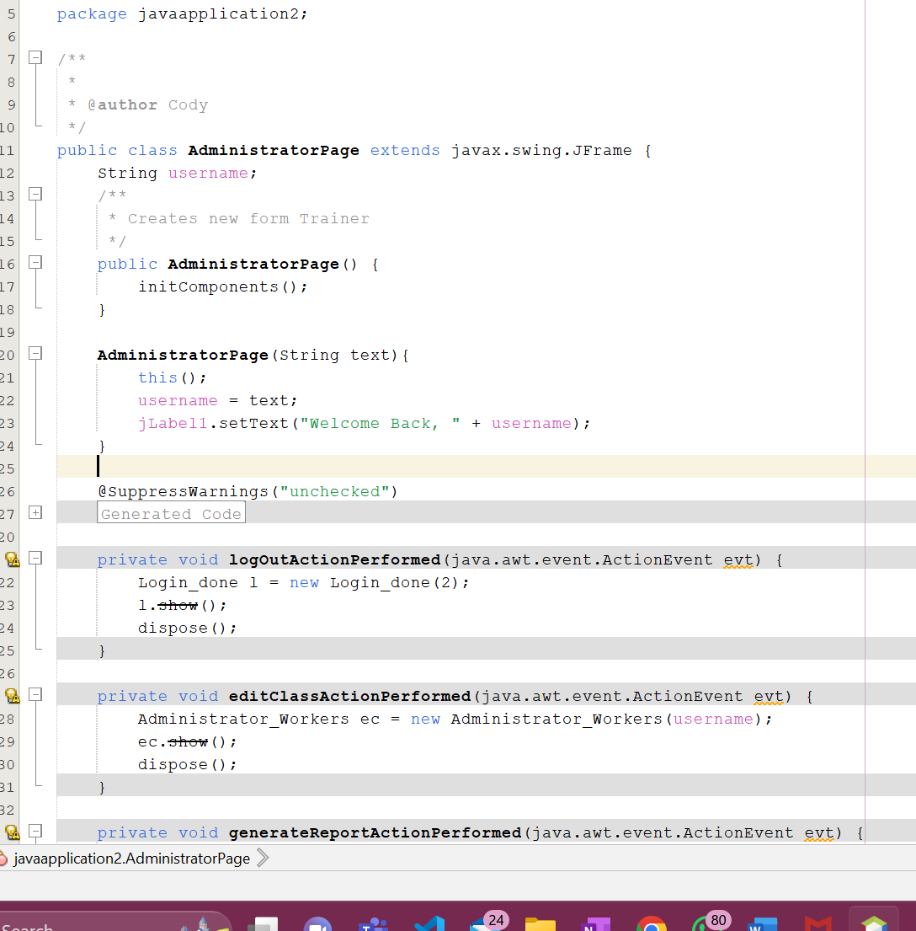

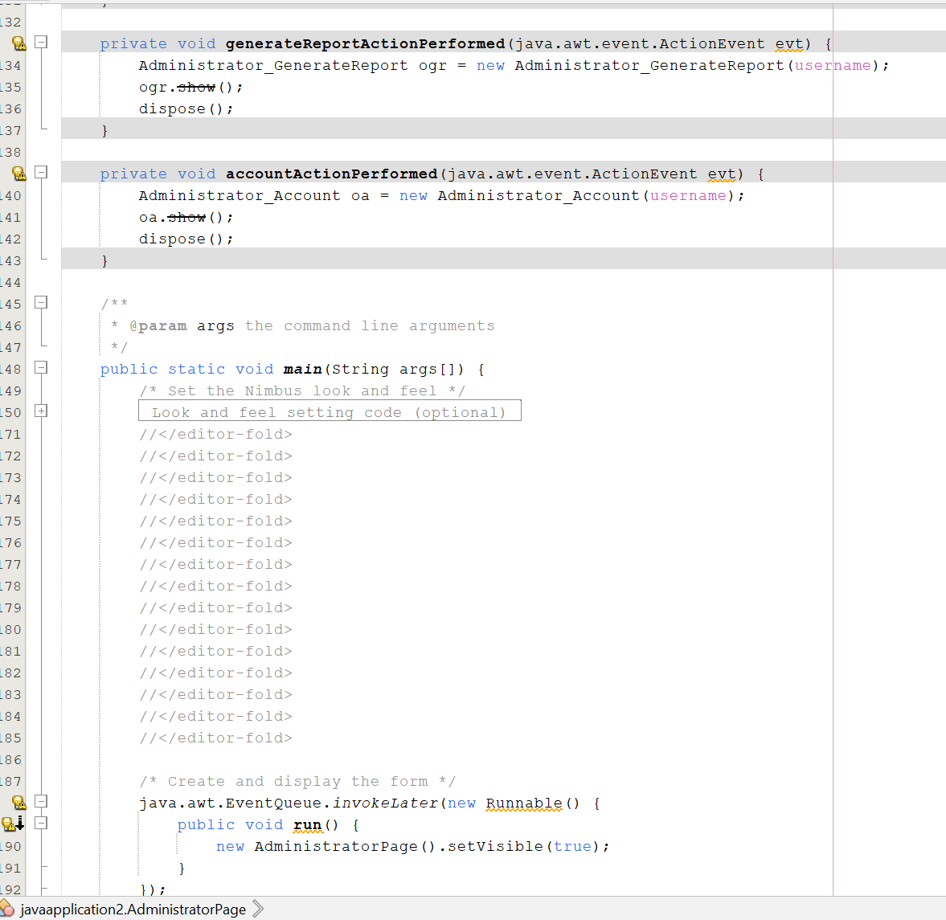

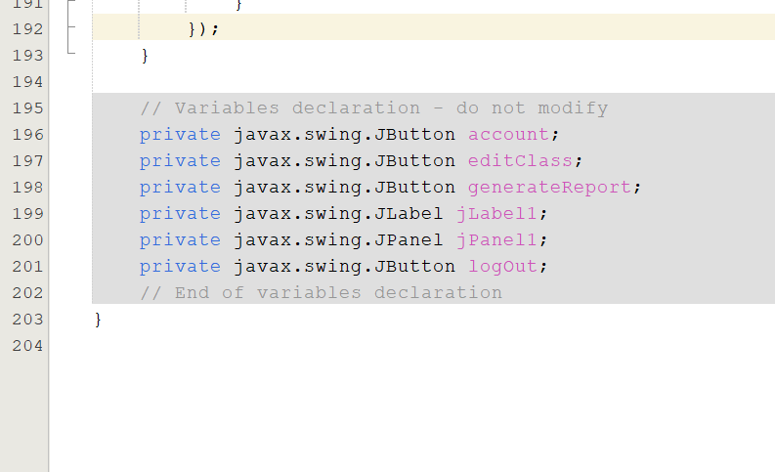

**GUI:**

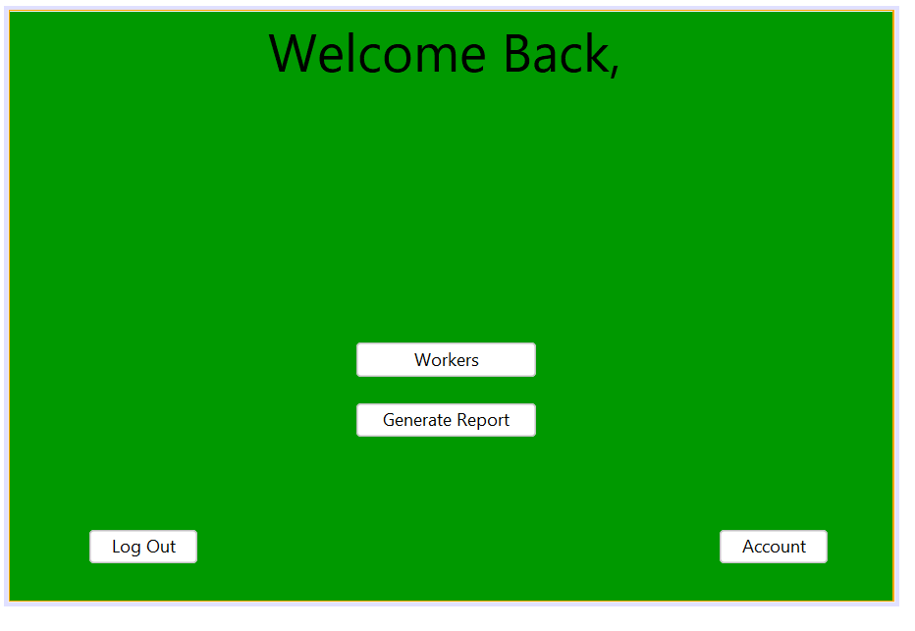

It appears that the class constructor receives the username variable, which enables the jLabel1 component to render a customised welcome message. Following "Welcome Back" is the alias on this label.   
When the Workers button (editClass) is clicked, the editClassActionPerformed method is called, which closes the graphical user interface and loads the Administrator_Workers page with the user's username.  
The generateReport action is initiated when the generateReport button (generateReport) is clicked. This action terminates the current window and launches Administrator_GenerateReport with the specified username in order to generate the report.   
  
To manage the administrator's account settings, this button invokes accountActionPerformed to open the Administrator_Account window and close the present one.   
The action listener for the logout icon (logOut) terminates the current window and initiates the Login_done process to log the user out.   
  
This method launches the application, configures the graphical user interface, and renders the AdministratorPage.

**Landing_done**

**CODE;**

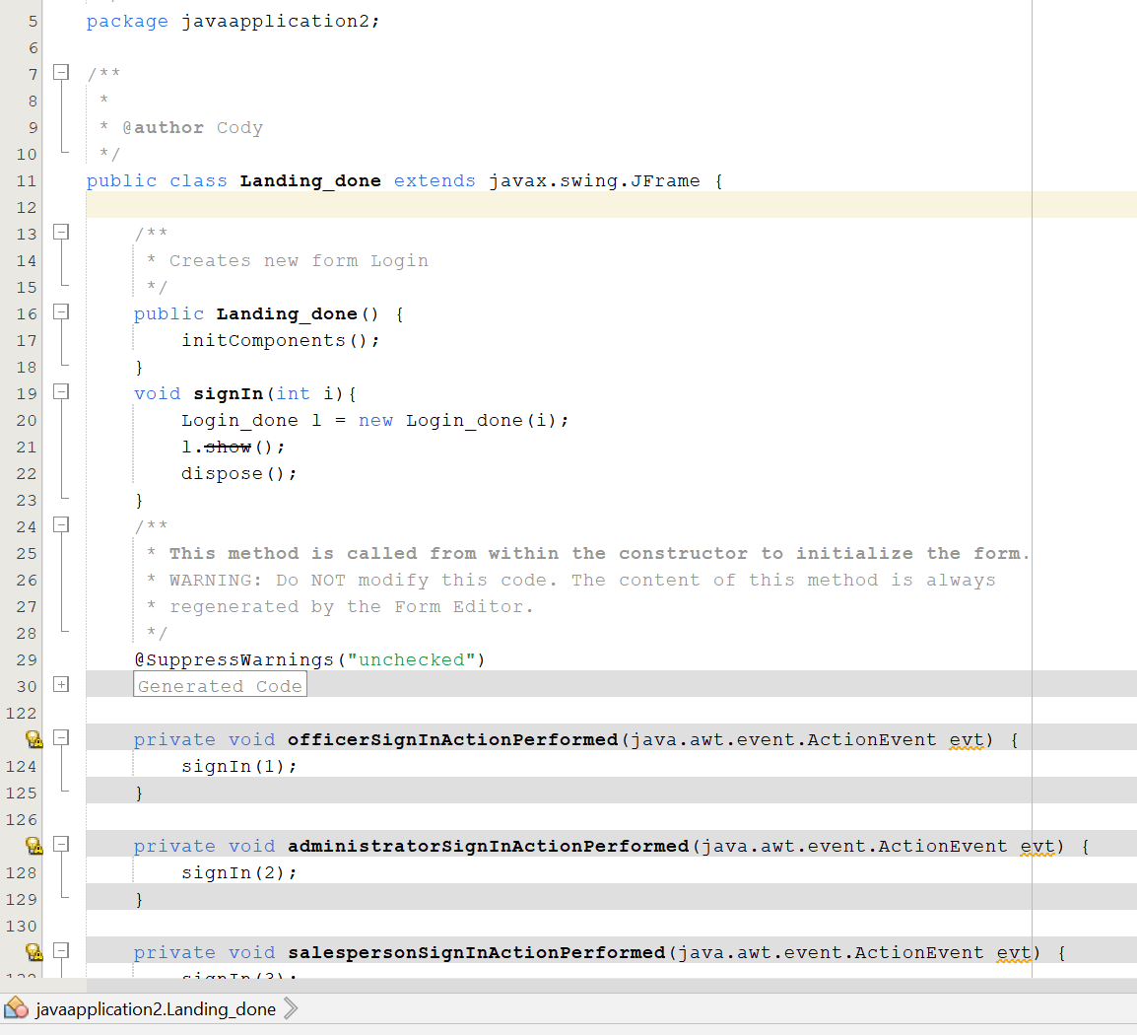

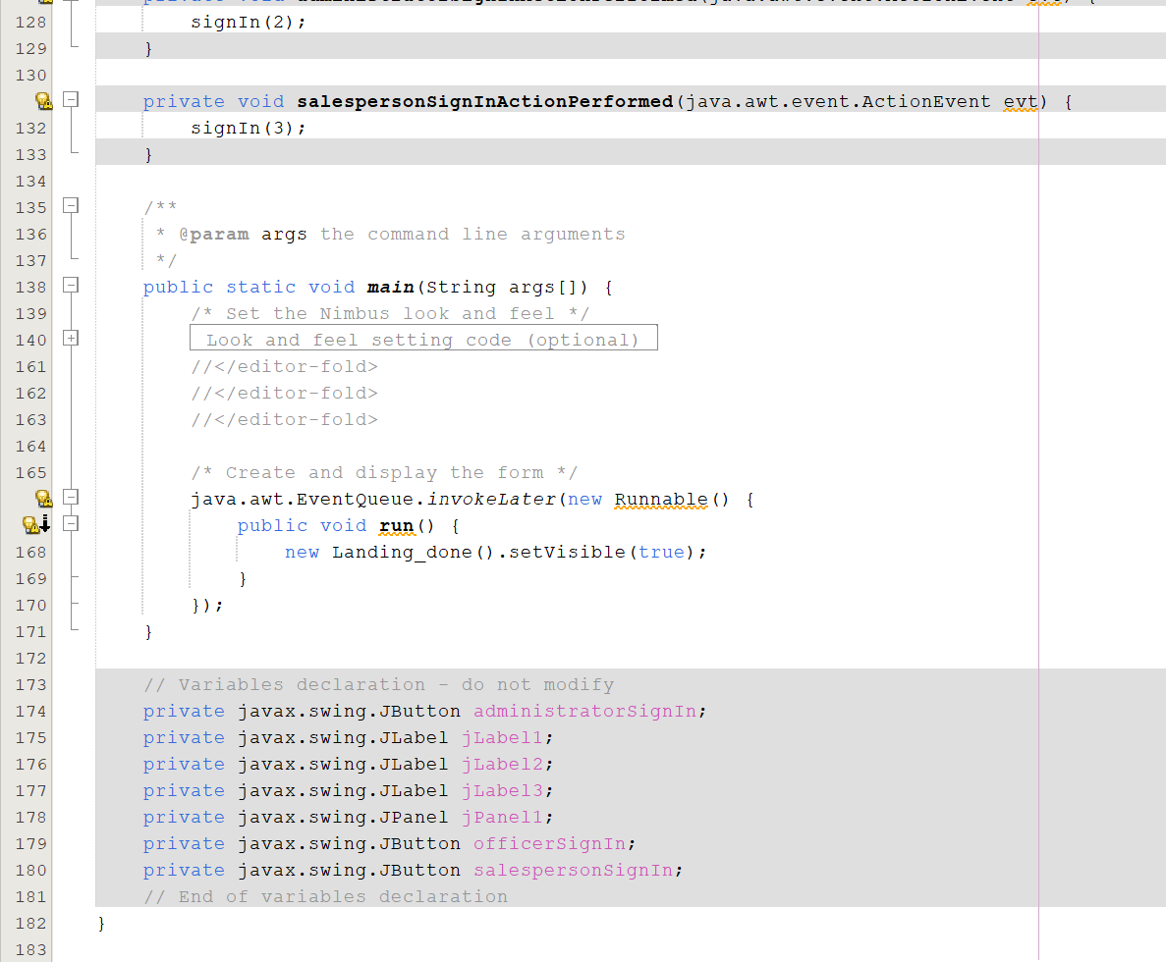

**GUI:**

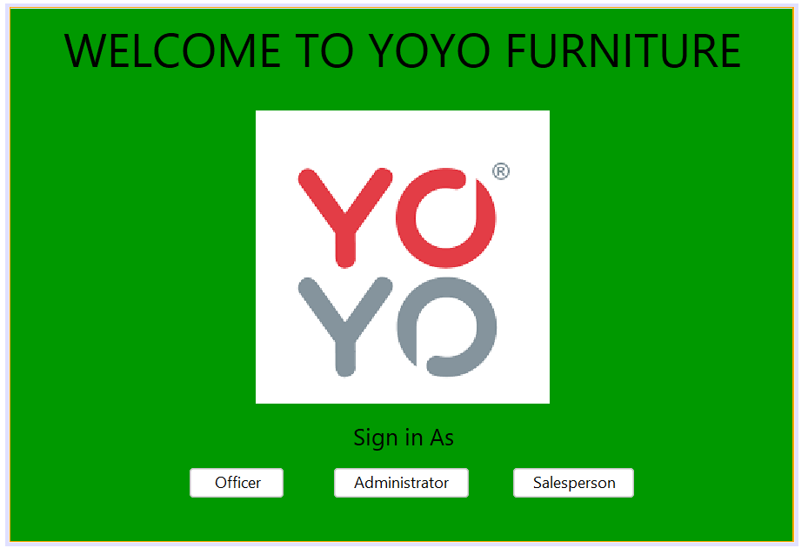

GUI windows, including Landing_done, extend JFrame. Without displaying their contents, the initComponents() method initialises components. It appears that the signIn() method generates a new Login_done window populated with an integer value that corresponds to the user role (e.g., officer, administrator, merchant).

The officerSalesperson, administratorSignInActionPerformed, and SignInActionPerformedDifferent integers are passed to signIn(int) via the SignInActionPerformed method in order to denote unique user categories.  
  
Main establishes the aesthetic and functional characteristics of the application and launches Landing_done. Using this technique, the GUI application is launched.

**Login_done**

**CODE:**

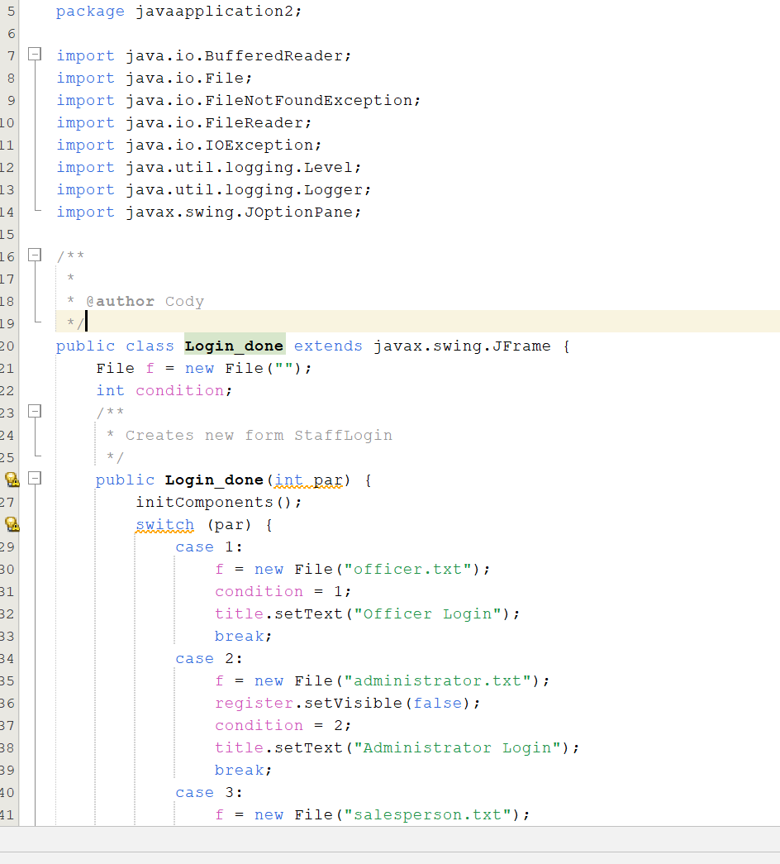 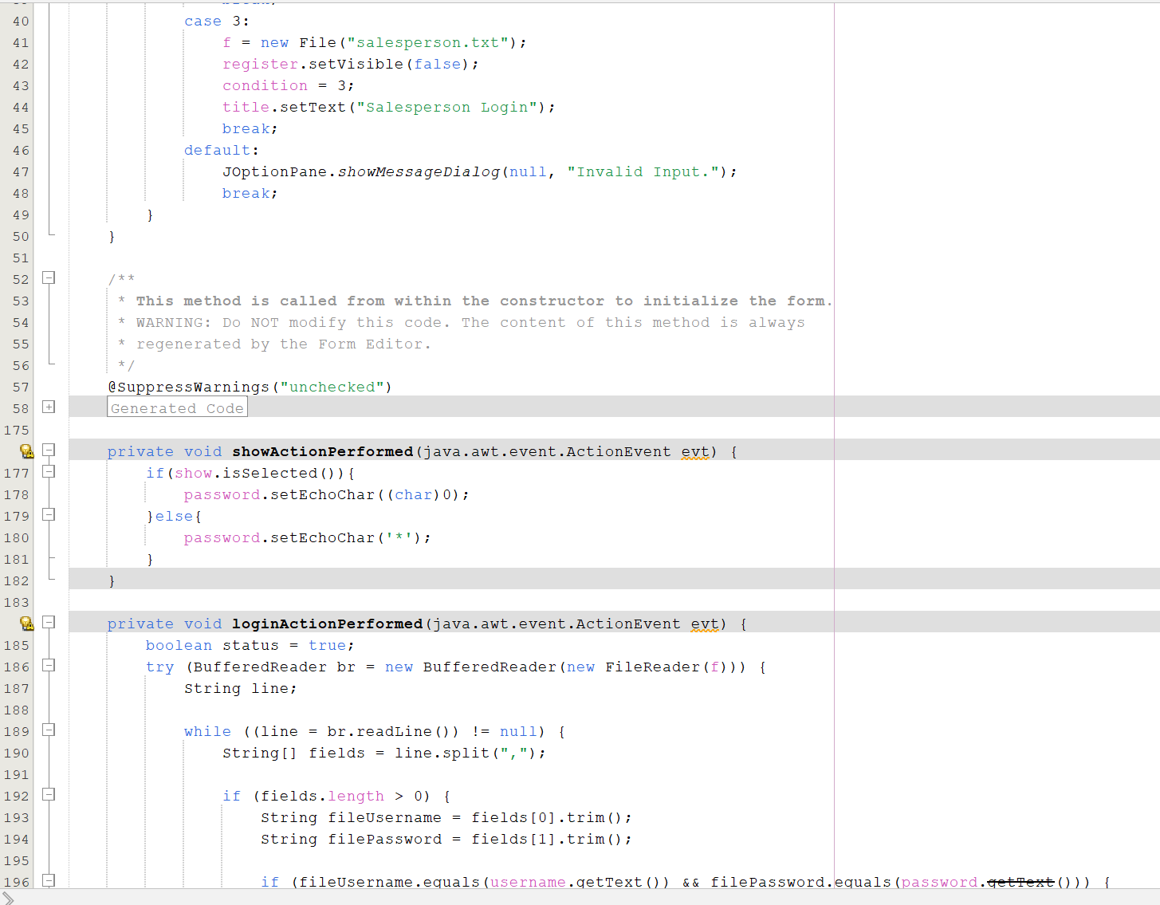 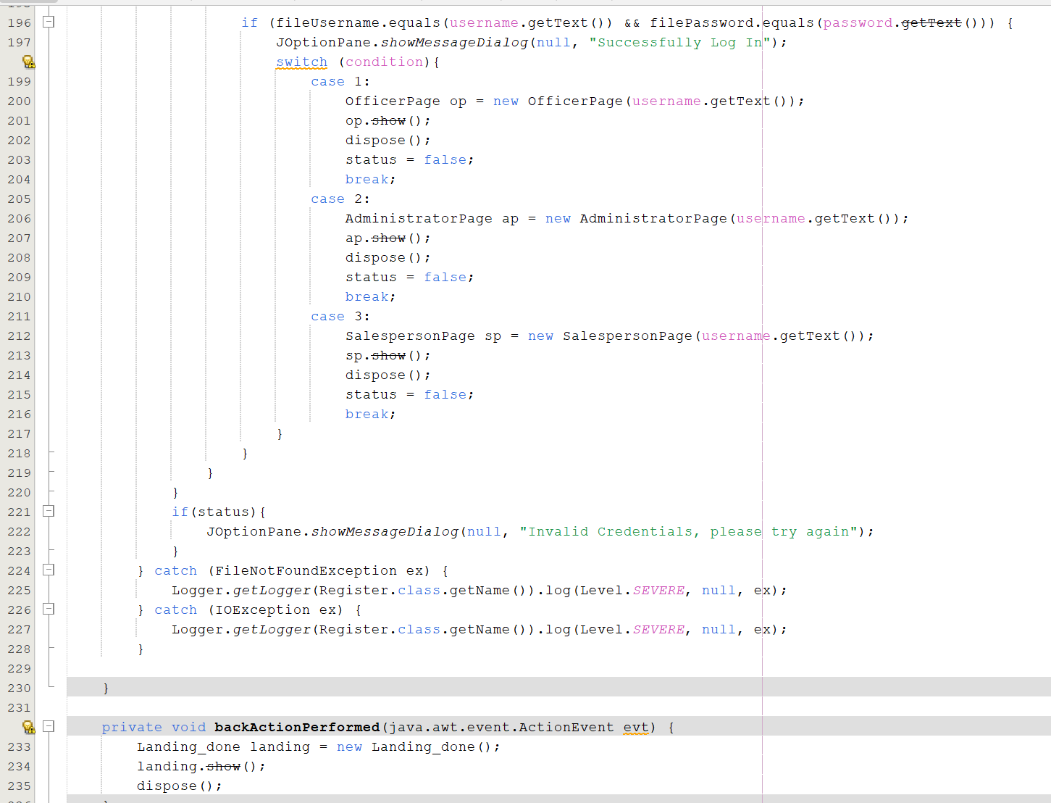 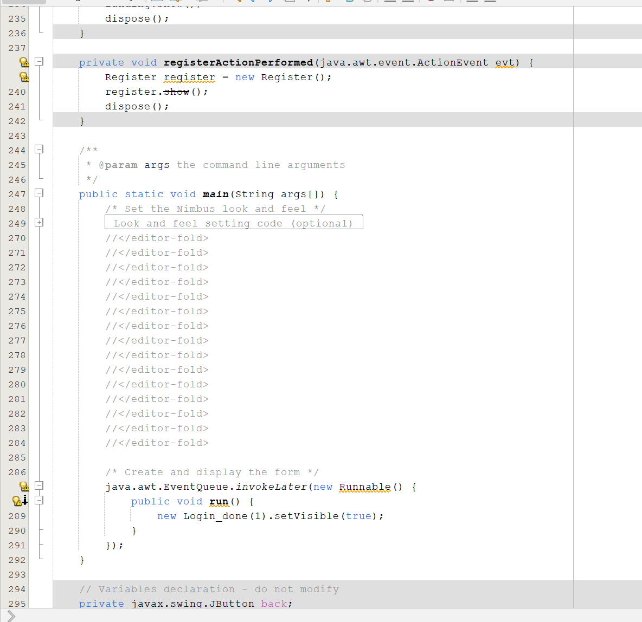 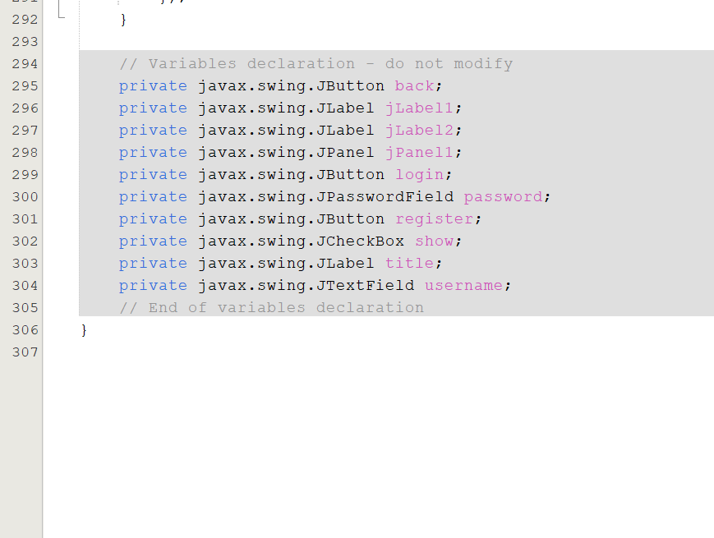

**GUI:**

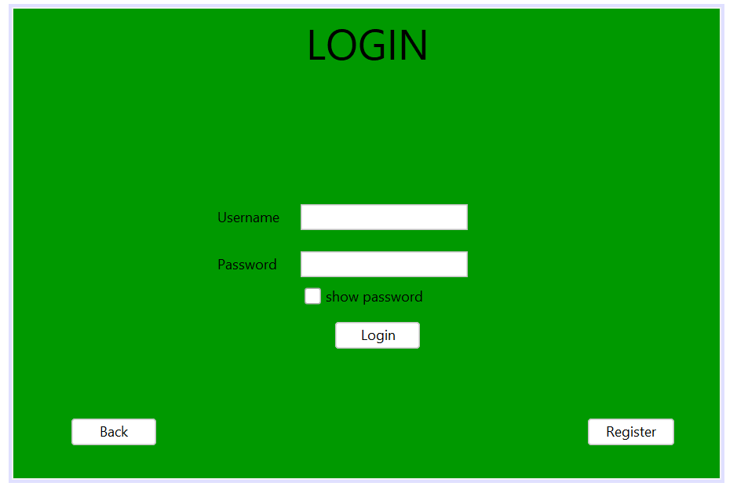

**ACCOUNT_LOGIN**

**CODE:**

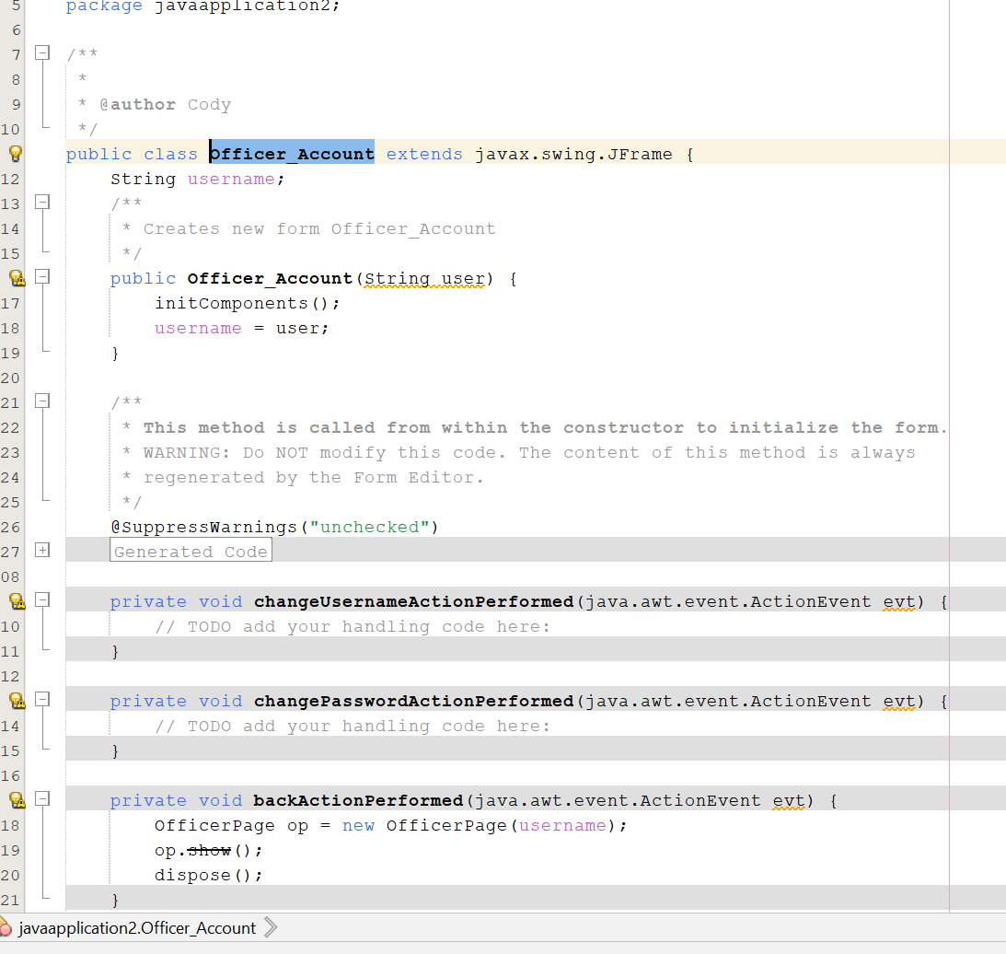

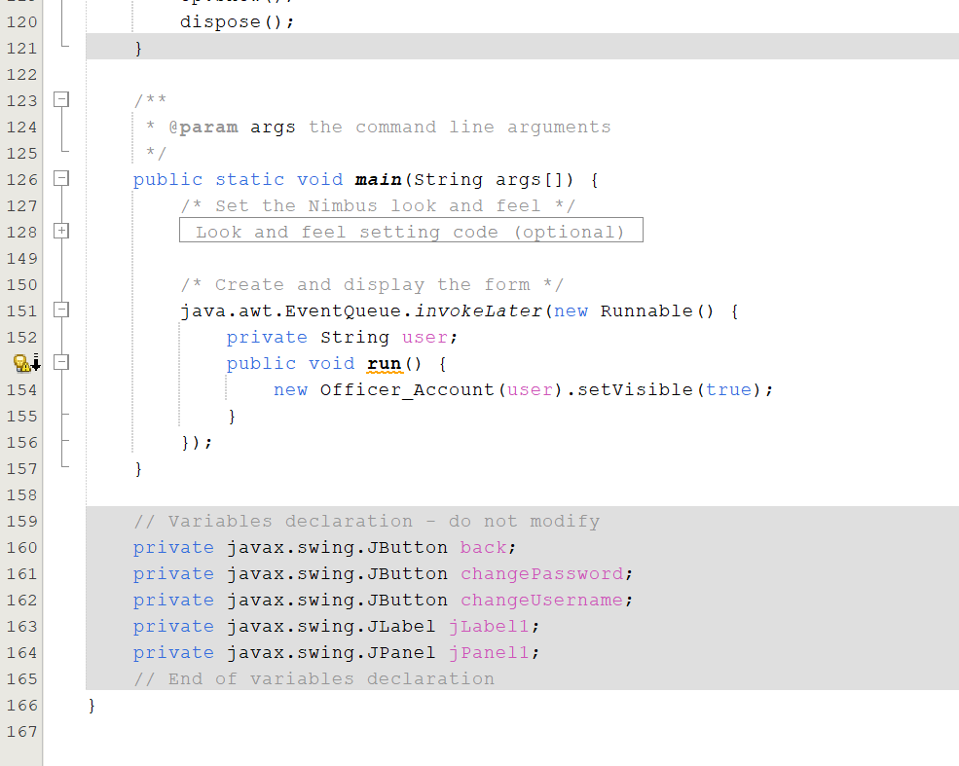

**GUI:**

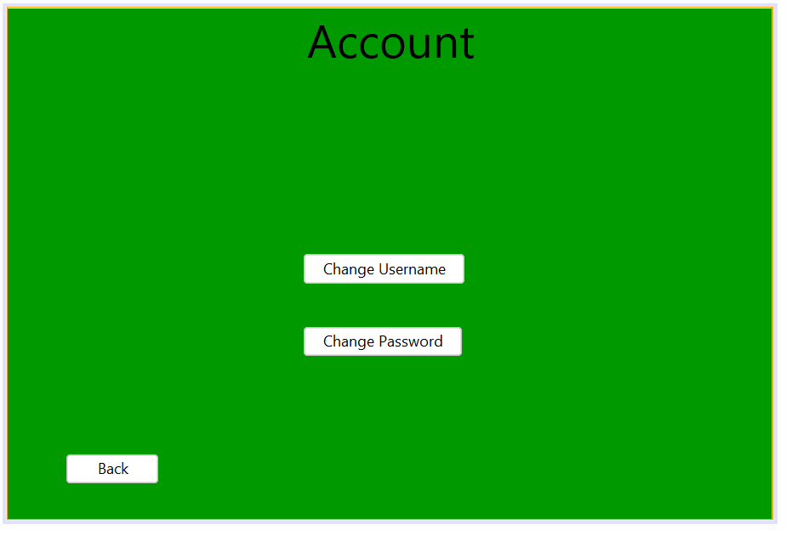

Page of Login GUI: To log in, enter your username and password. By analysing text files for user credentials, the Login_done class authorises access to user pages according to the user's role (e.g., officer, administrator, salesperson).   
  
Landing Page GUI: Users are redirected to their role-specific landing page upon logging in. Users can view sales history, submit sales, verify product status, generate reports, manage accounts, or log out via the icons that appear on this page.

# 9.0 ADDITIONAL FEATURES

### 9.1.0 BACKGROUND IMAGE

**CODE:**

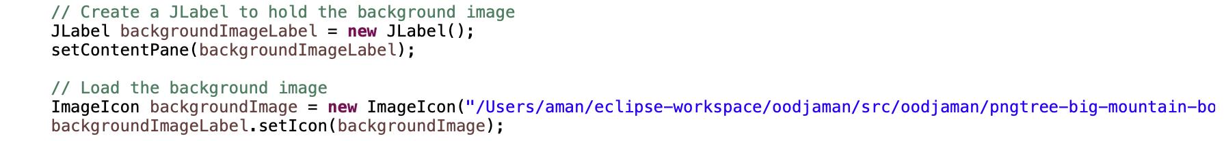

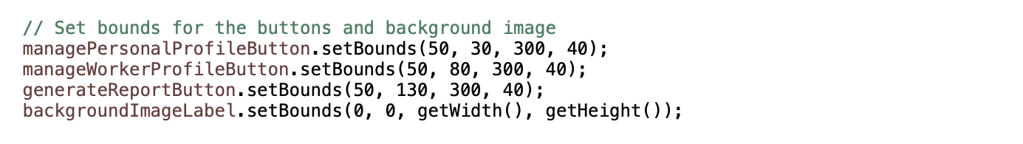

**GUI:**



### 9.1.1 STYLED BUTTONS

**CODE:**

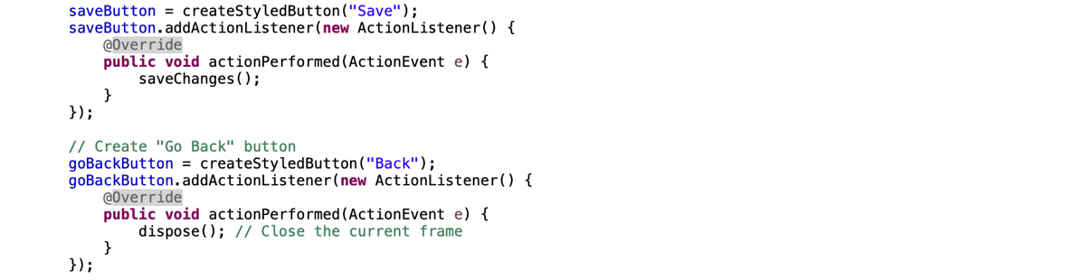

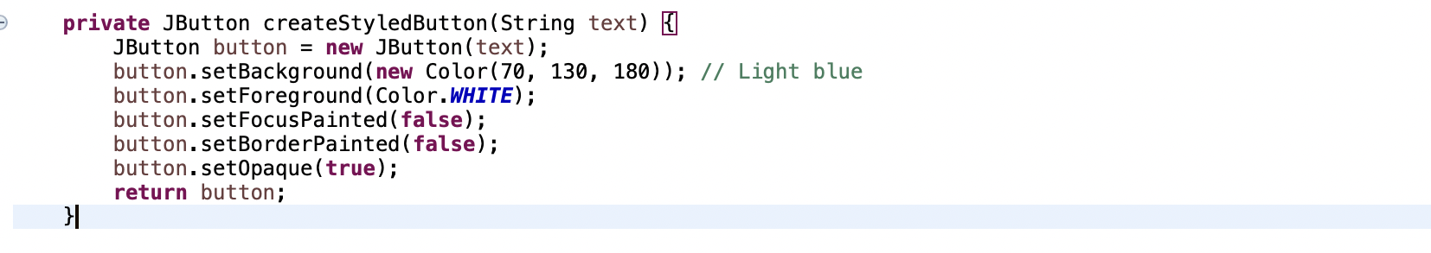

**GUI:**



### 9.1.2 GRADIENT COLOUR BACKGROUND

**CODE:**

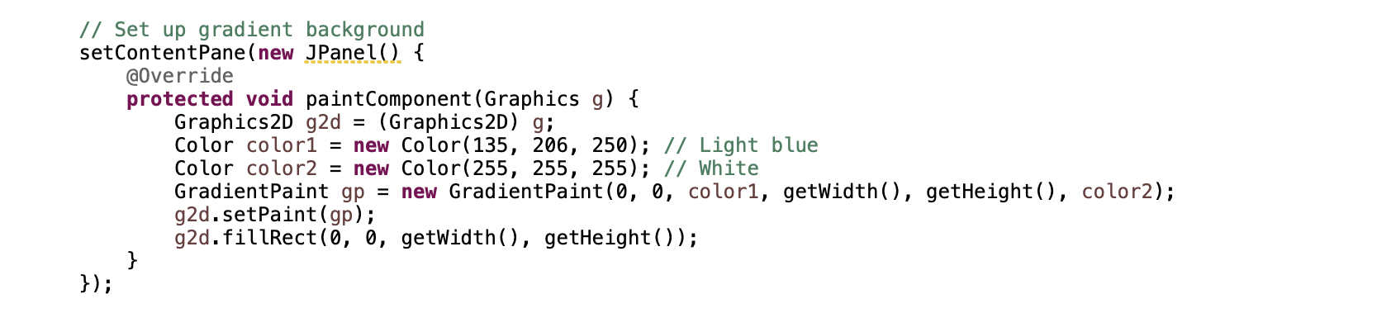

**GUI:**



### 9.1.3 TIMER FOR DIALOG BOX

**CODE:**

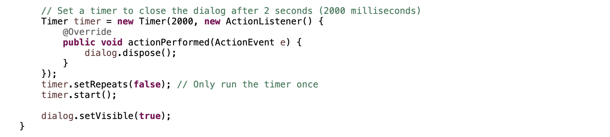

**GUI:**

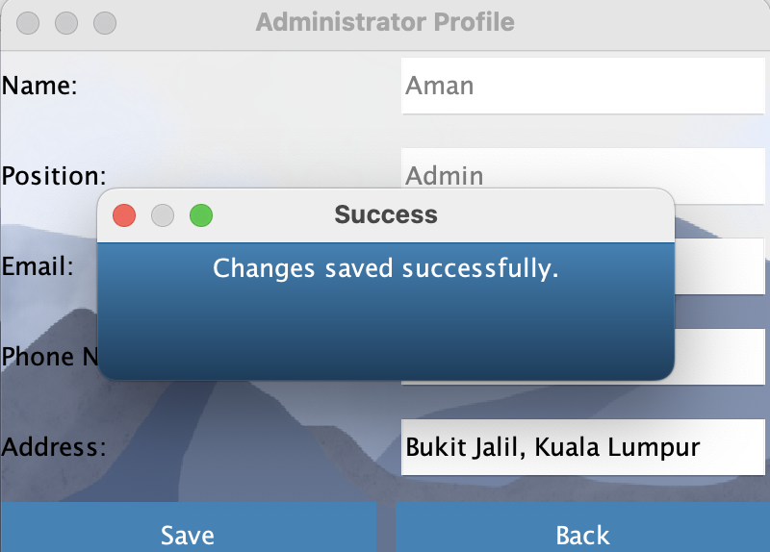

### 9.1.3 ALTERNATING ROW COLOURS

**CODE:**

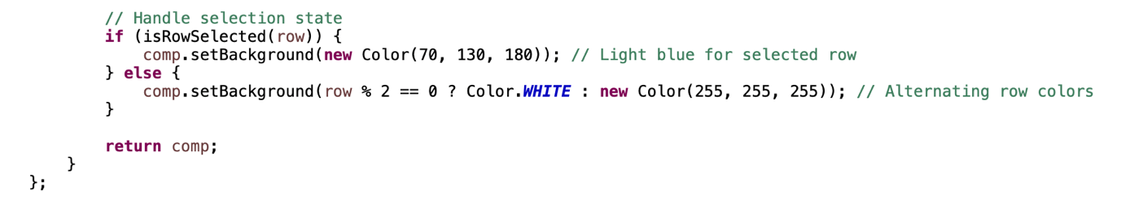

**GUI:**

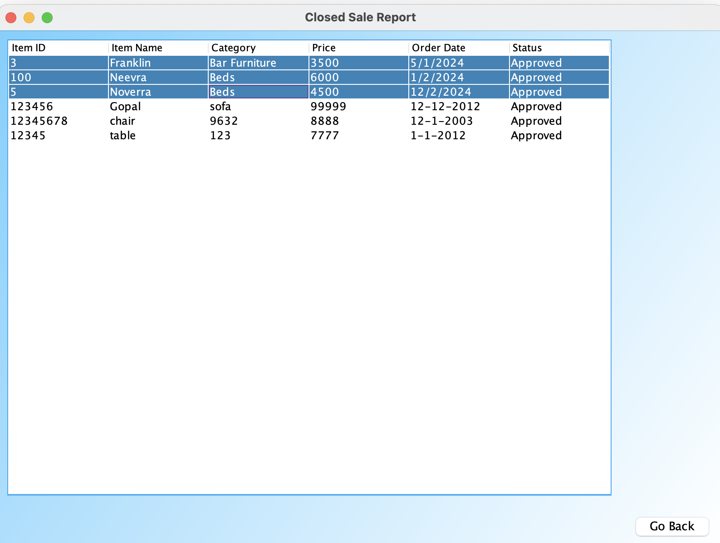

### 9.1.4 CENTERING FRAME TO SCREEN

**CODE:**



**GUI:**

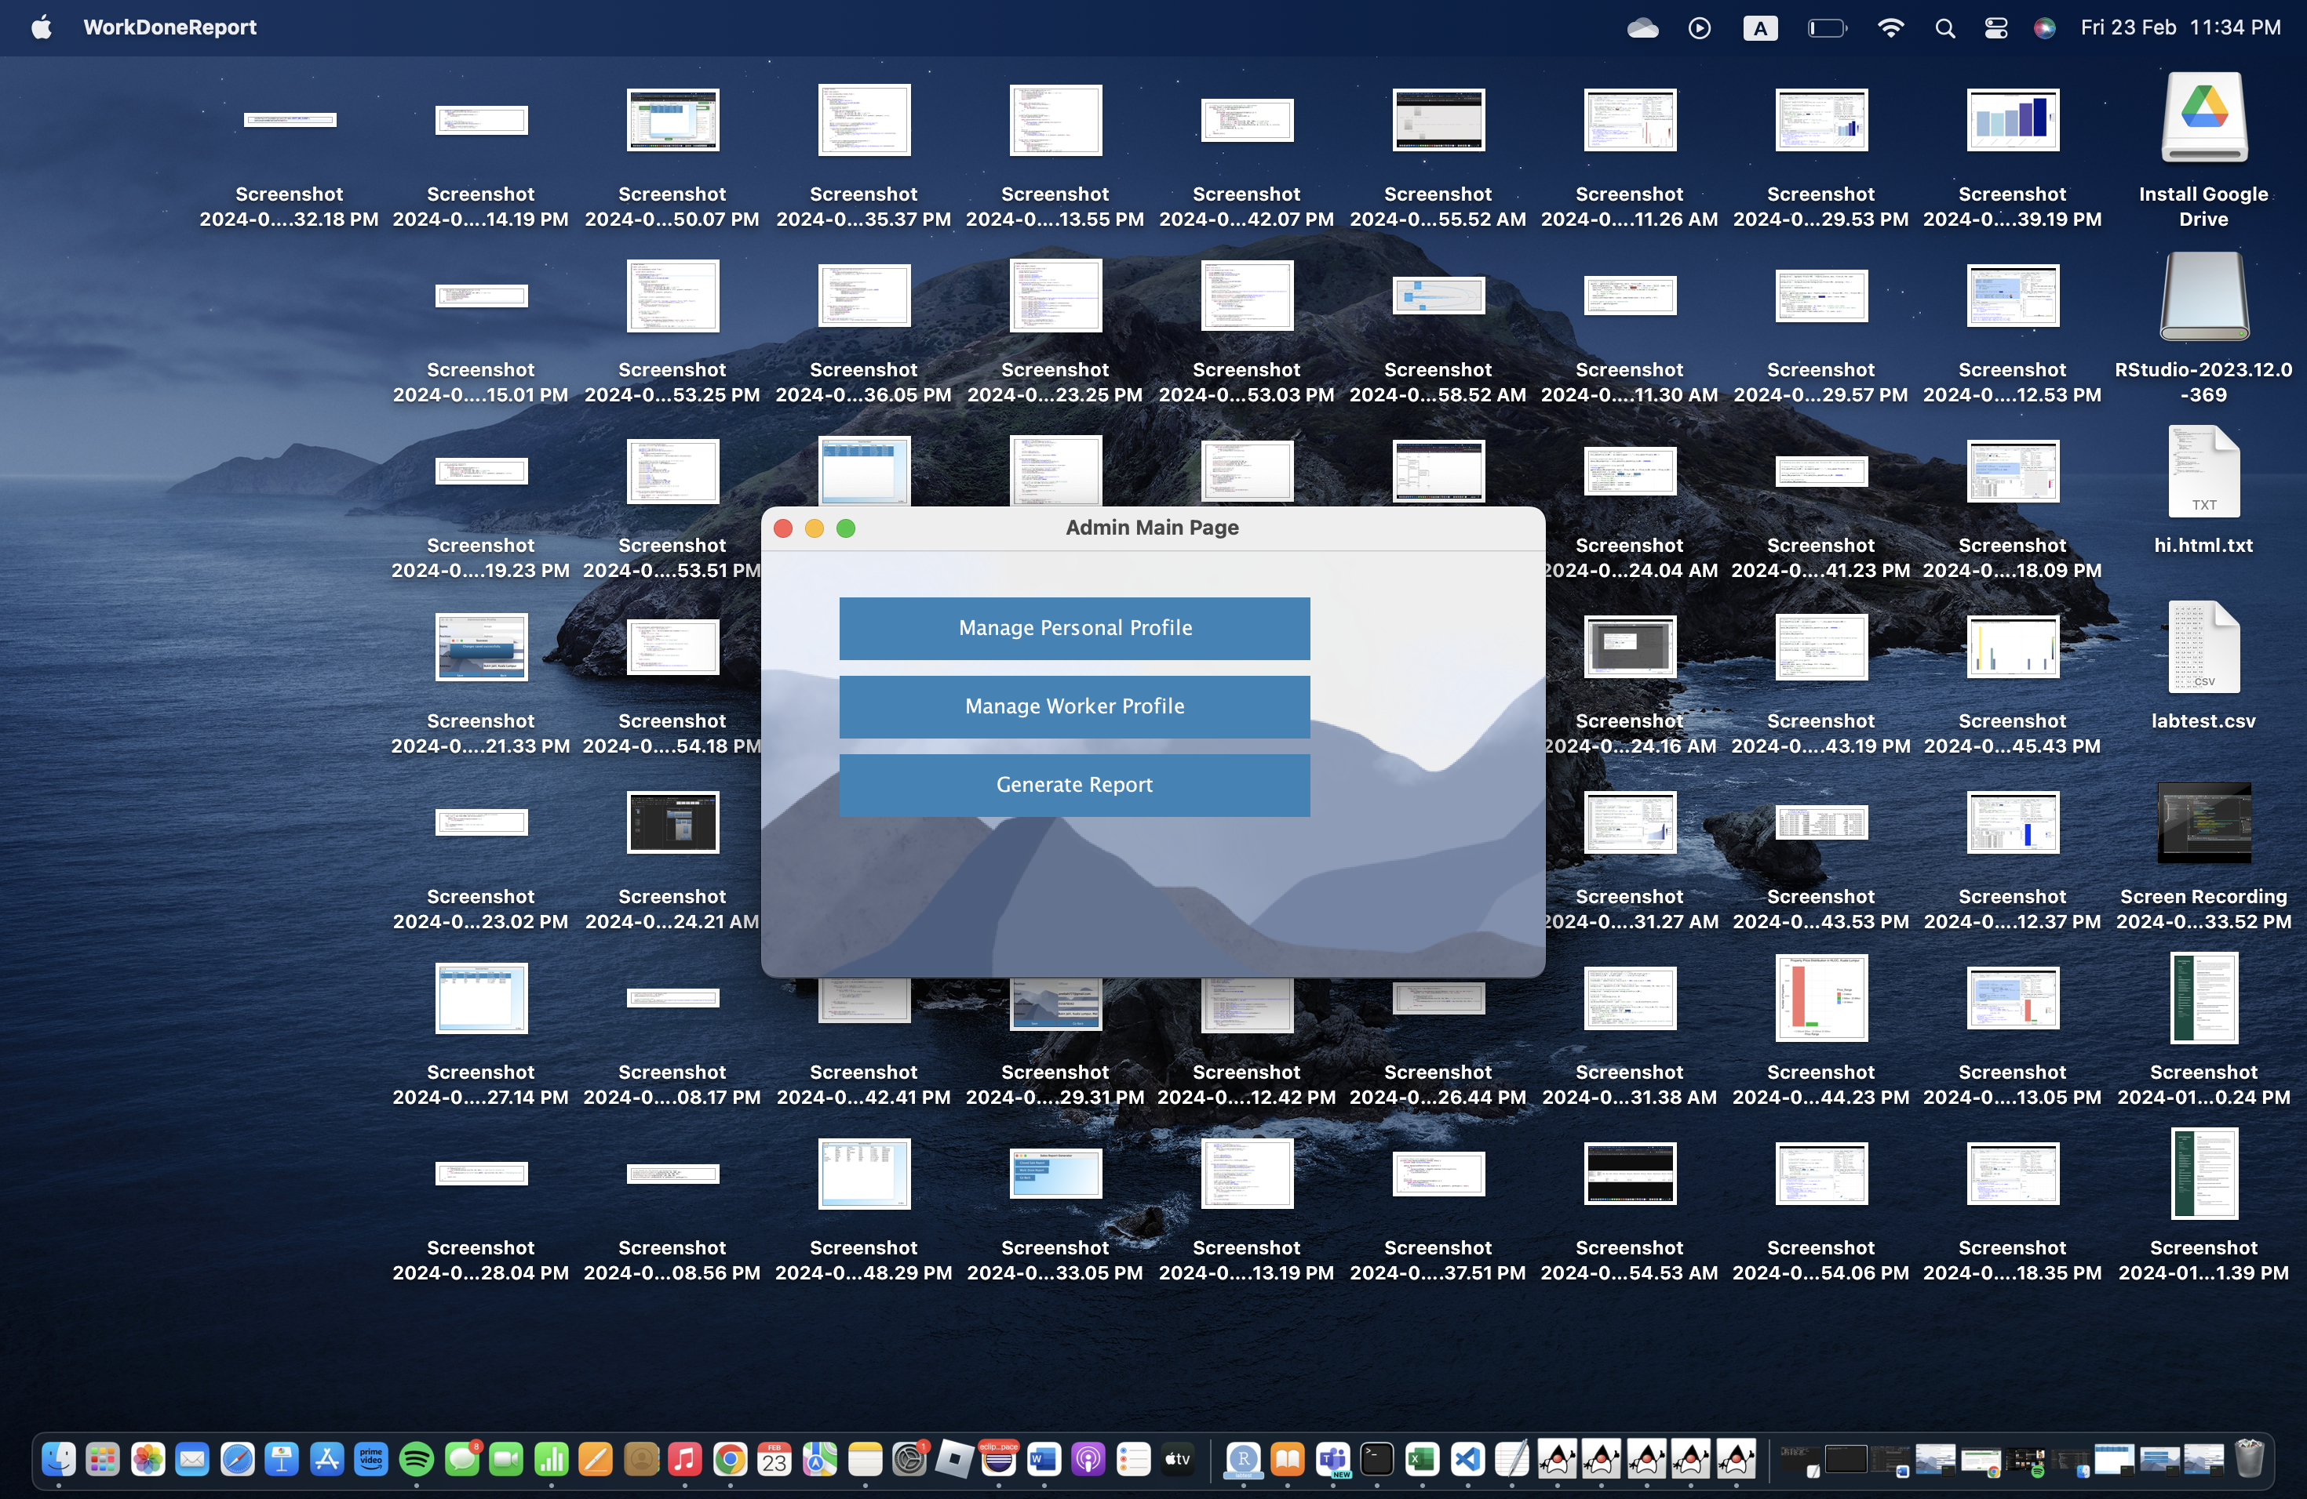

# 10.0 CONCLUSION

To sum up, the Yoyo-Furniture Sales Management System provides a comprehensive approach to addressing the difficulties encountered by the furniture enterprise in overseeing its sales activities. The system offers a user-friendly interface and strong functionality for simplifying sale order processing, invoice production, report generation, and product administration by using contemporary technology and object-oriented design concepts. The system reduces possible security concerns by providing officers, administrators, and salespeople with safe access control using authentication and authorization processes. All things considered, the Yoyo-Furniture Sales Management System is expected to improve productivity, accuracy, and efficiency in duties linked to sales, which will eventually help the firm succeed and expand in the highly competitive industry.